**Ramniranjan Jhunjhunwala College of Arts, Science and Commerce**

**Department of Data Science and Artificial Intelligence**

**CERTIFICATE**

**This is to certify that Ankita Adhik Kanse of Msc. Data Science and Artificial Intelligence Roll No 731 has successfully completed the practical of Paper – I(Semester-III) MACHINE LEARNING - II during the Academic Year 2023-2024.**

**Date :**

**(Prof. Mujtaba Shaikh)  
 Prof-In-Charge External Examiner**

**INDEX**

| **SR.NO** | **PRACTICAL NAME** | **DATE** | **REMARK** |
| --- | --- | --- | --- |
| **Unit I : Cross Validation** | | | |
| **1.1** | **Implementation of any 4 types of Cross Validation technique** | **21-06-2023** | **Completed** |
| **Unit II : Regularization** | | | |
| **2.1** | **Implementation of L2 Regularization** | **26-06-2023** | **Completed** |
| 2.2 | Demonstrate how coefficient affected by increasing the values of the lambda (alpha). | 27-06-2023 | **Completed** |
| 2.3 | In Ridge regression prove that “The more higher coefficient are affected more.” | 27-06-2023 | **Completed** |
| **2.4** | **Implementation of LASSO Regression** | **03-07-2023** | **Completed** |
| **Unit II : Ensemble Learning** | | | |
| **3.1** | **Implementation of Voting Ensemble Learning** | **11-07-2023** | **Completed** |
| **3.2** | **Implementation of Bagging technique** | **14-07-2023** | **Completed** |
| **3.3** | **Implementation of Gradient Boosting** | **21-07-2023** | **Completed** |
| **3.4** | **Implementation of Stacking** | **28-07-2023** | **Completed** |
| **Unit III : Unsupervised Learning - Clustering** | | | |
| **3.5** | **Implementation of K-Means Clustering** | **04-08-2023** | **Completed** |
| **3.6** | **Implementation of Agglomerative Clustering** | **08-08-2023** | **Completed** |
| **3.7** | **Implementation of Density Based Spacial Clustering of Applications with Noise (DBSCAN) Algorithm** | **18-08-2023** | **Completed** |
| **Unit IV : Unsupervised Learning - Association rule learning** | | | |
| **4.1** | **Perform Market Basket Analysis using Apriori Algorithm.** | **25-08-2023** | **Completed** |
|  |  |  |  |
|  |  |  |  |
|  |  |  |  |

**Unit I**

**Practical 1.1**

**Aim : Implementation of any 4 types of Cross-Validation techniques.**

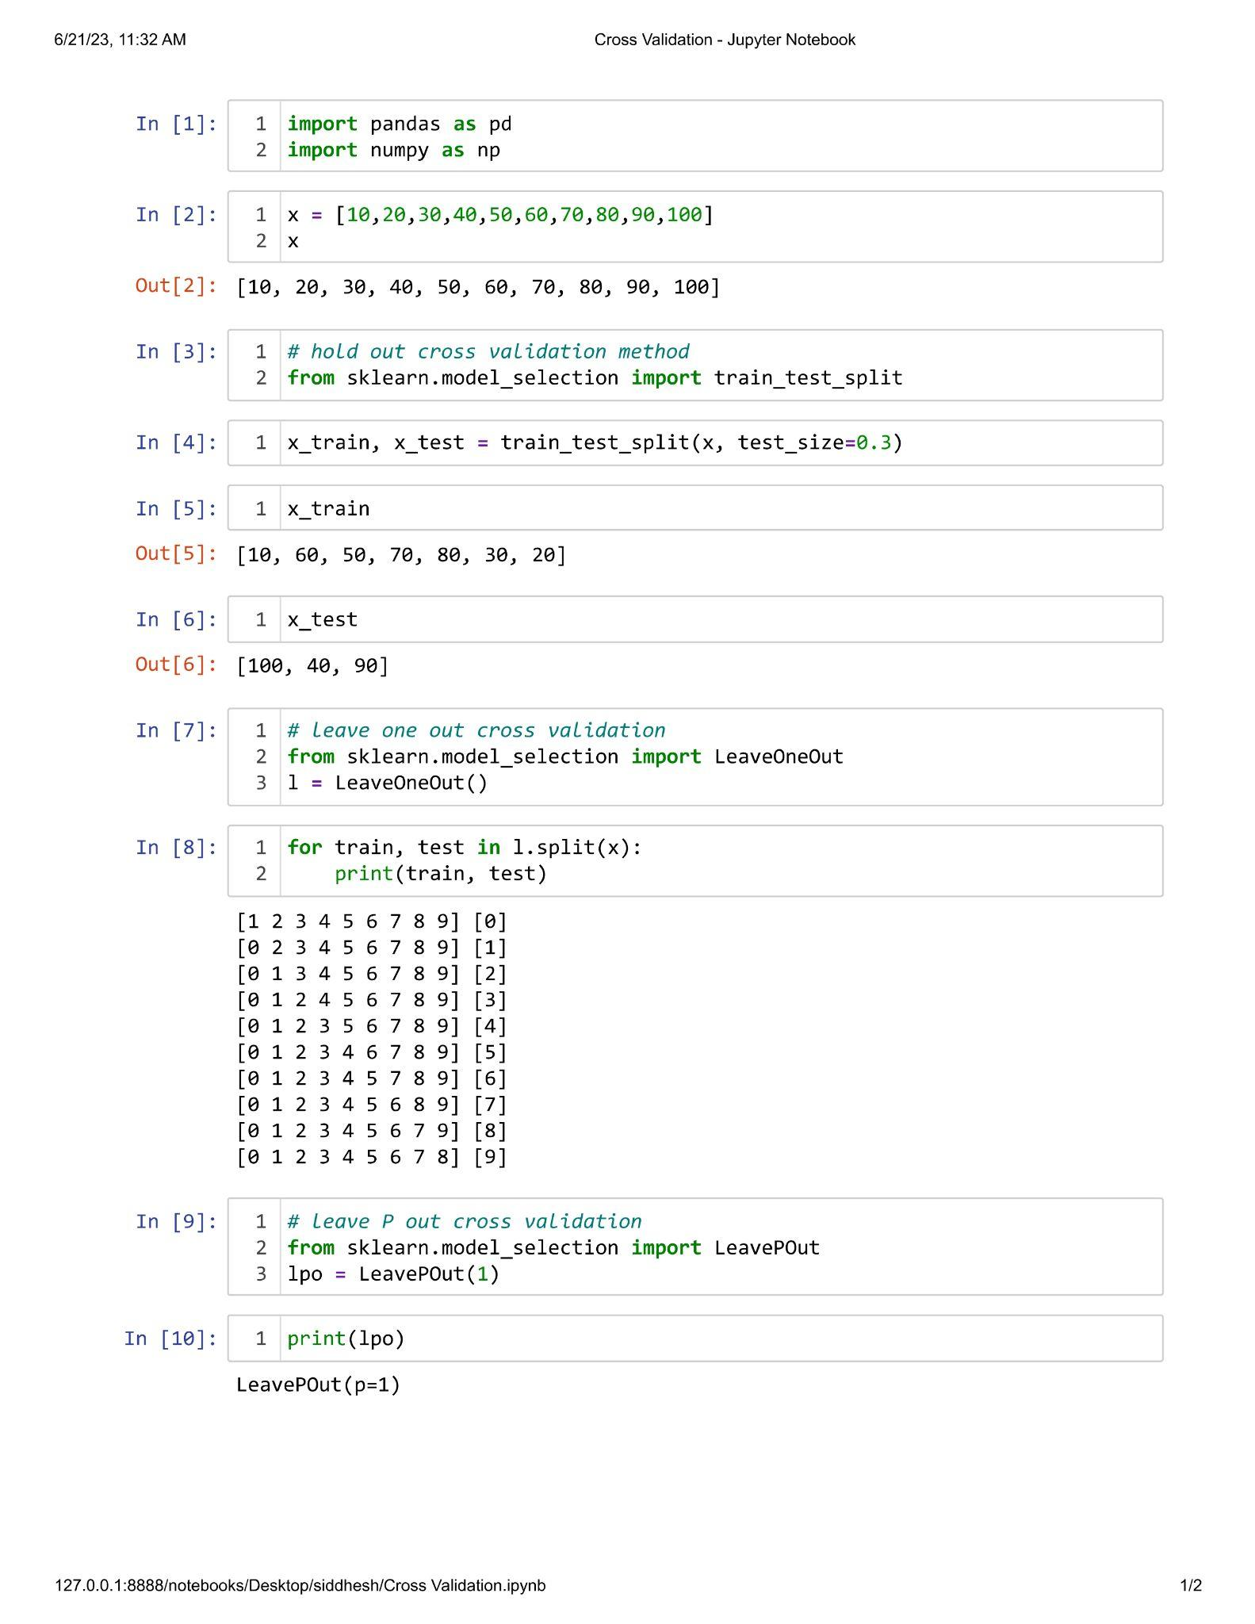

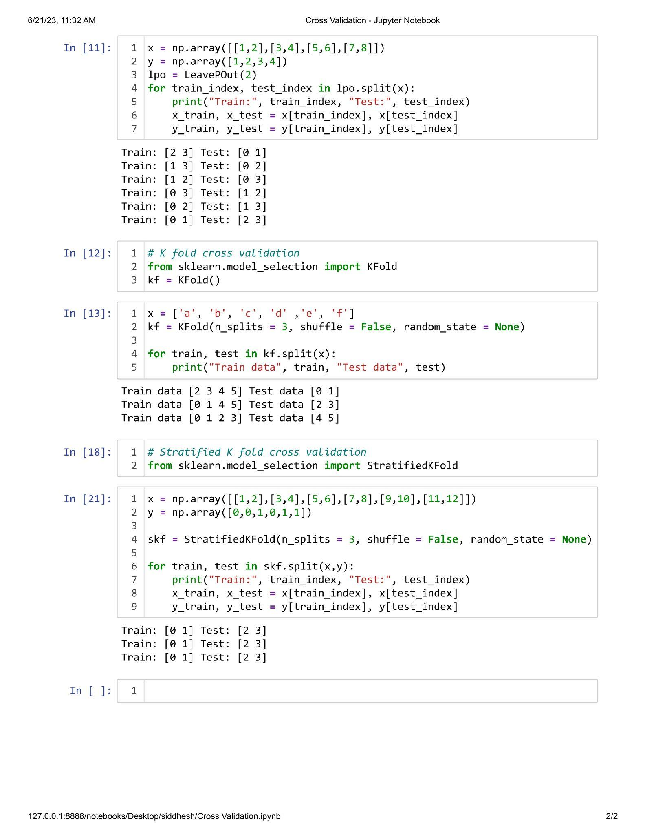

**Unit II**

**Practical 2.1**

**Aim : Implementation of L2 Regularization.**

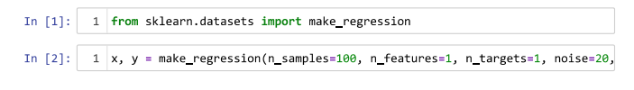



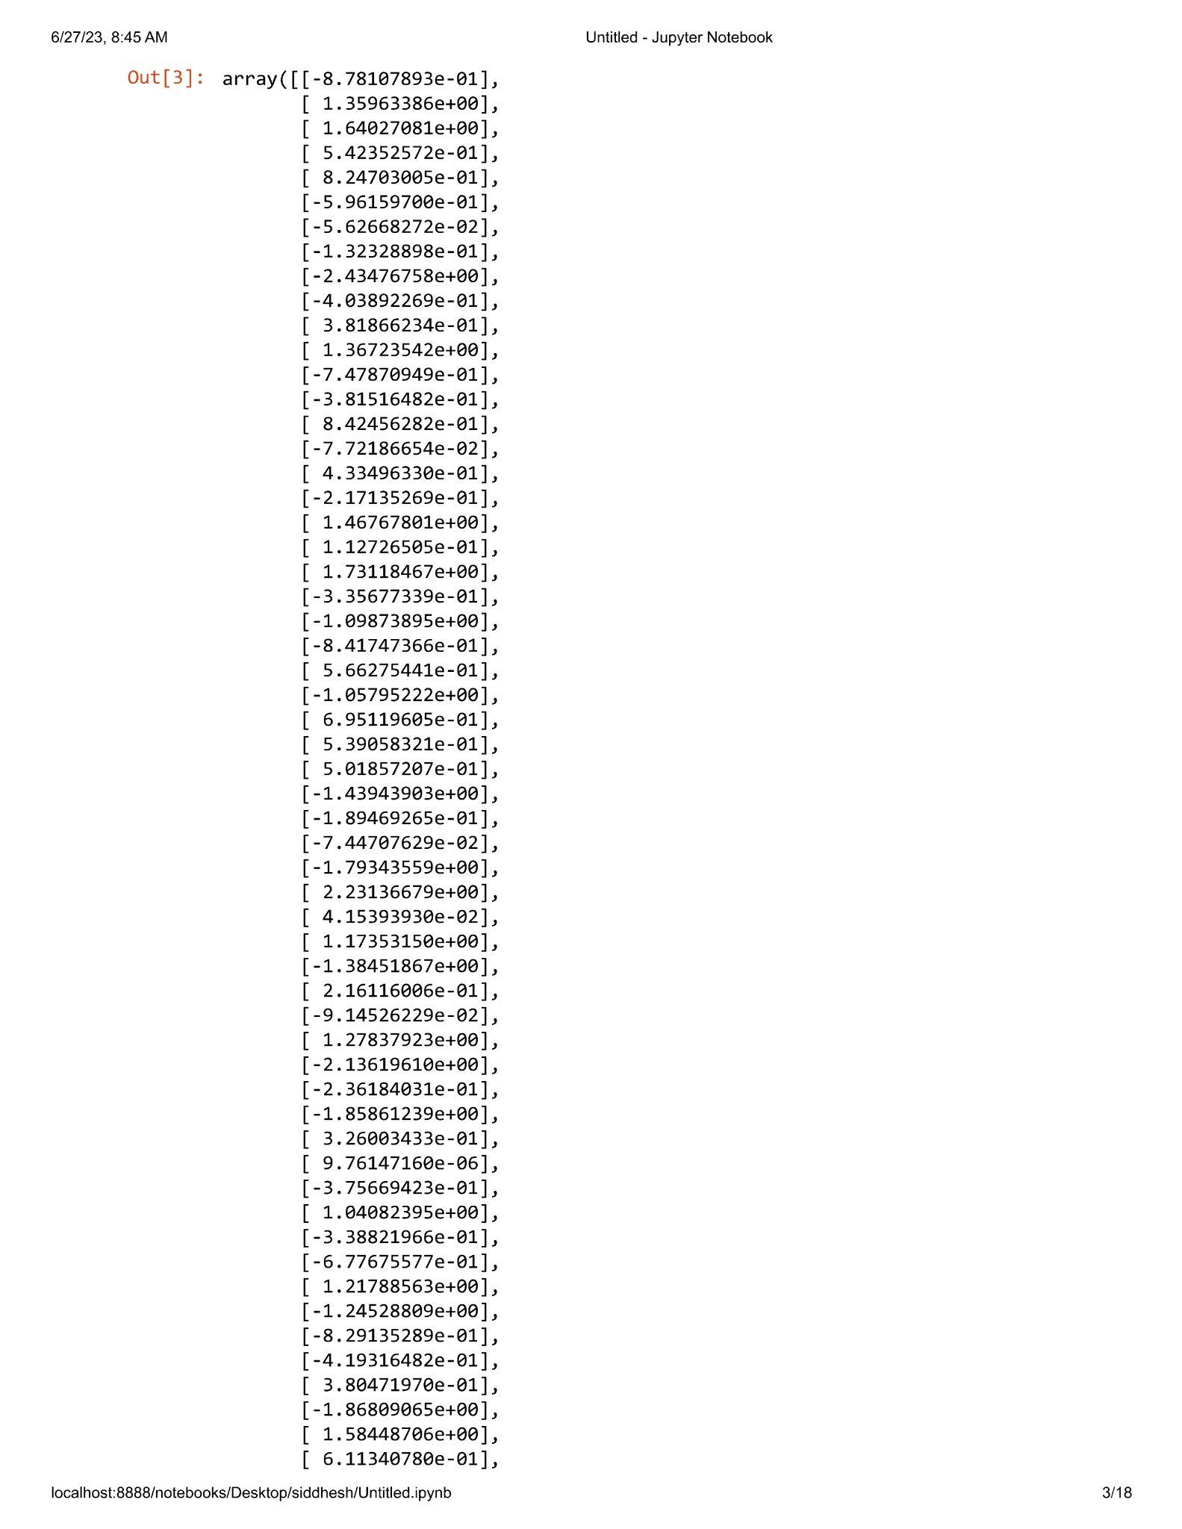

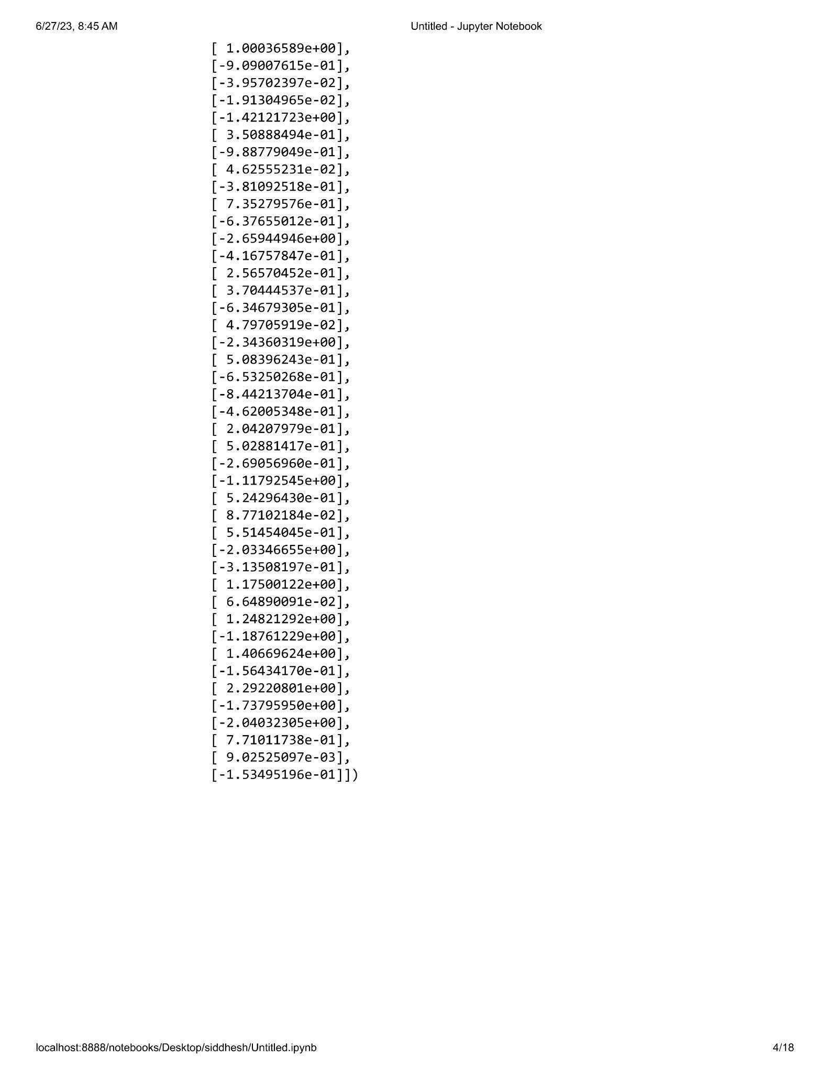

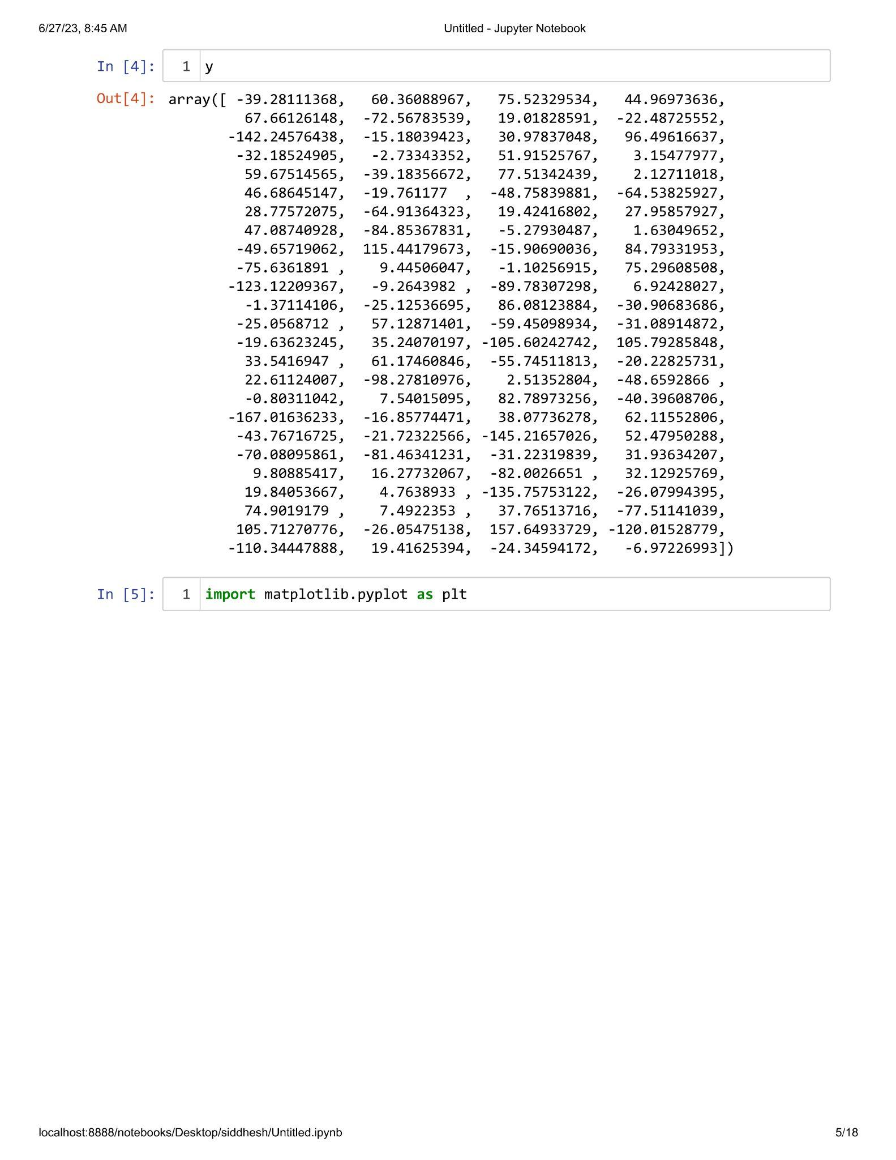

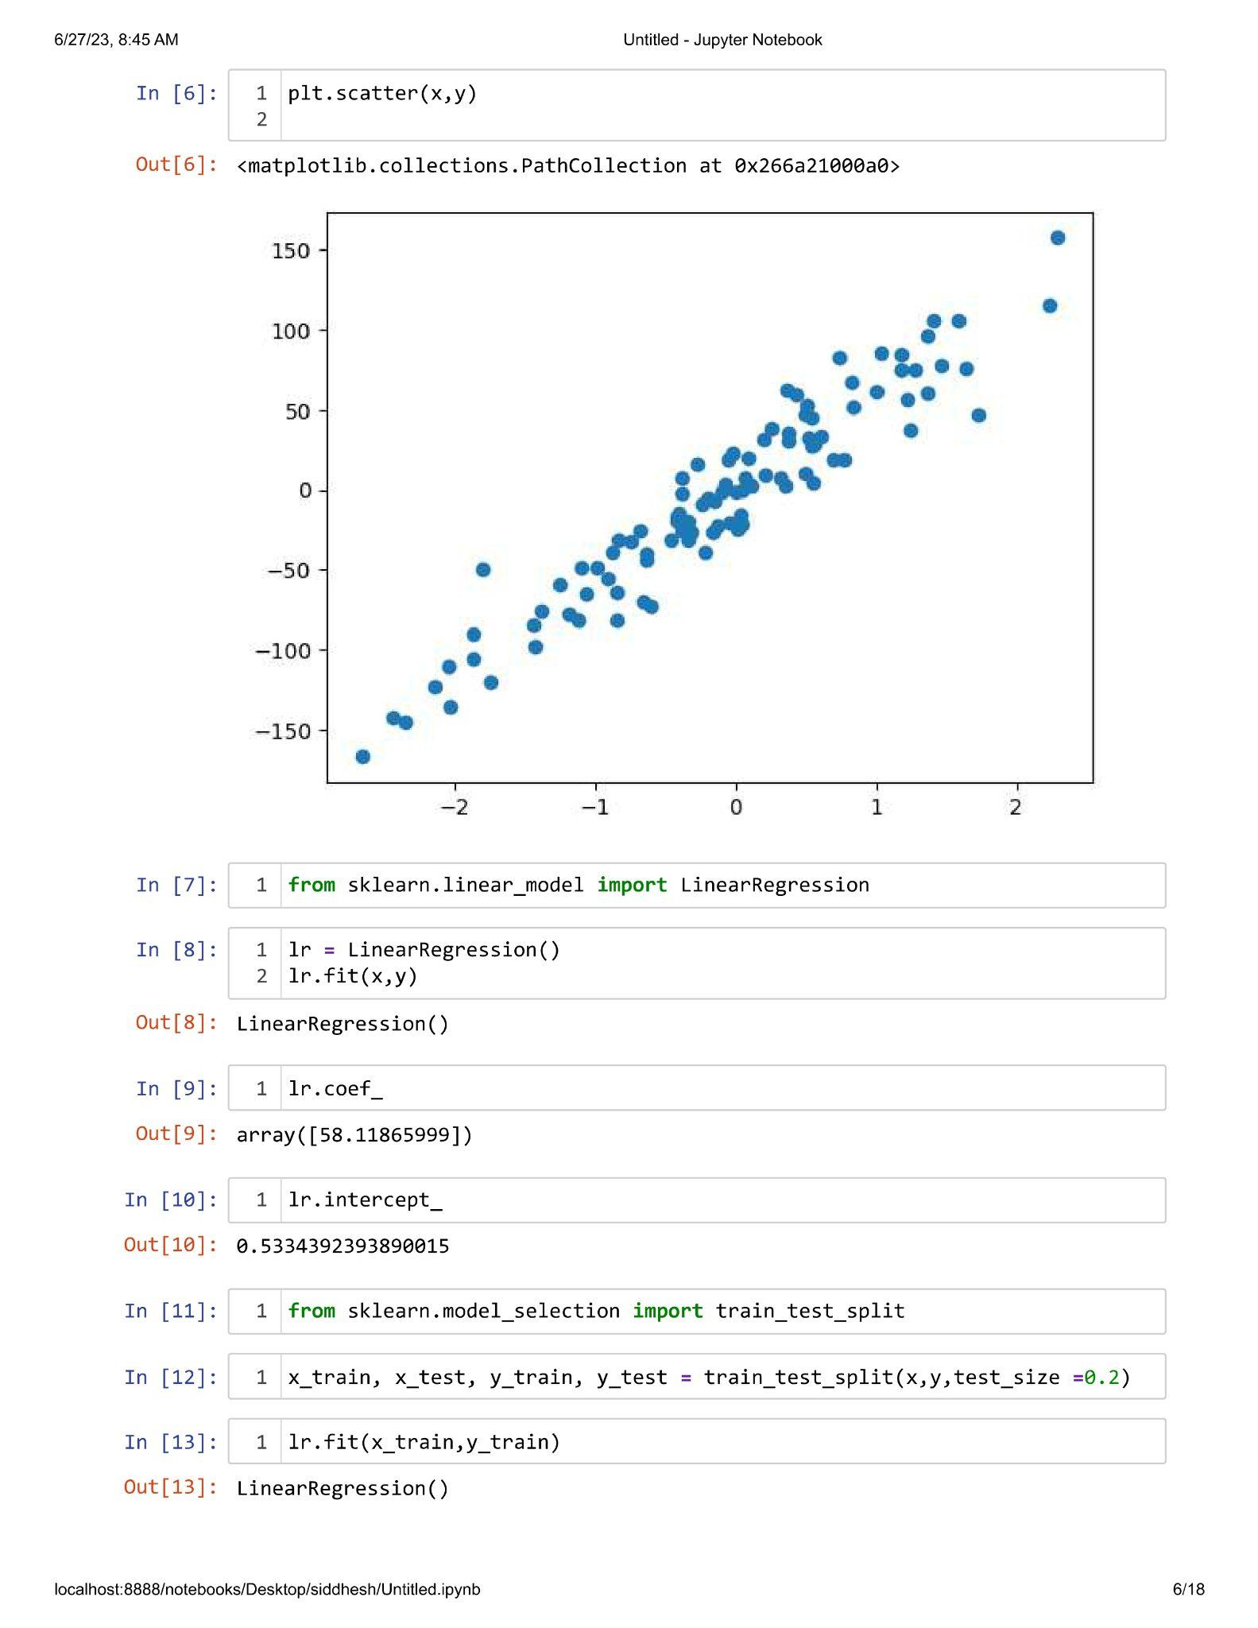

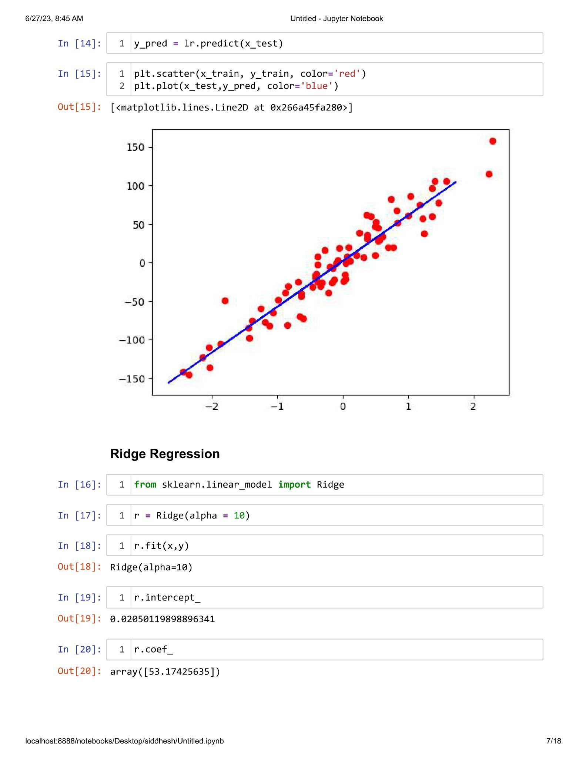

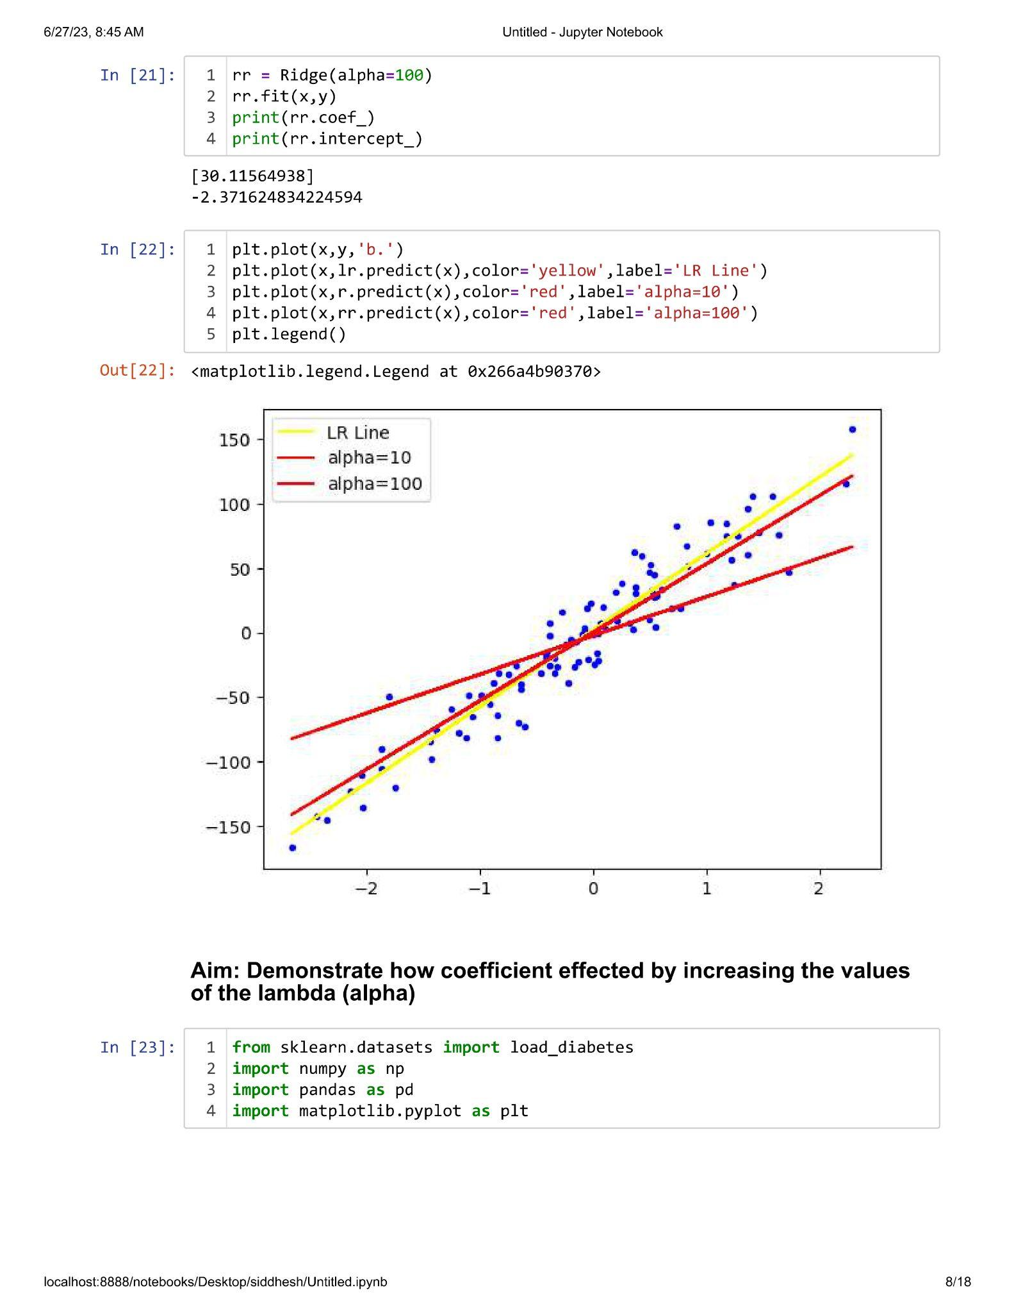

**Practical 2.2**

**Aim : Demonstrate how co-efficient gets affected by increasing values of the lambda(Alpha).**

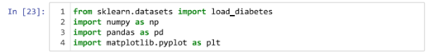



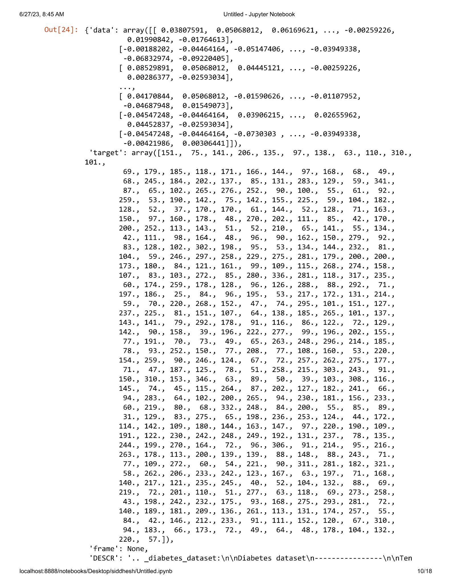

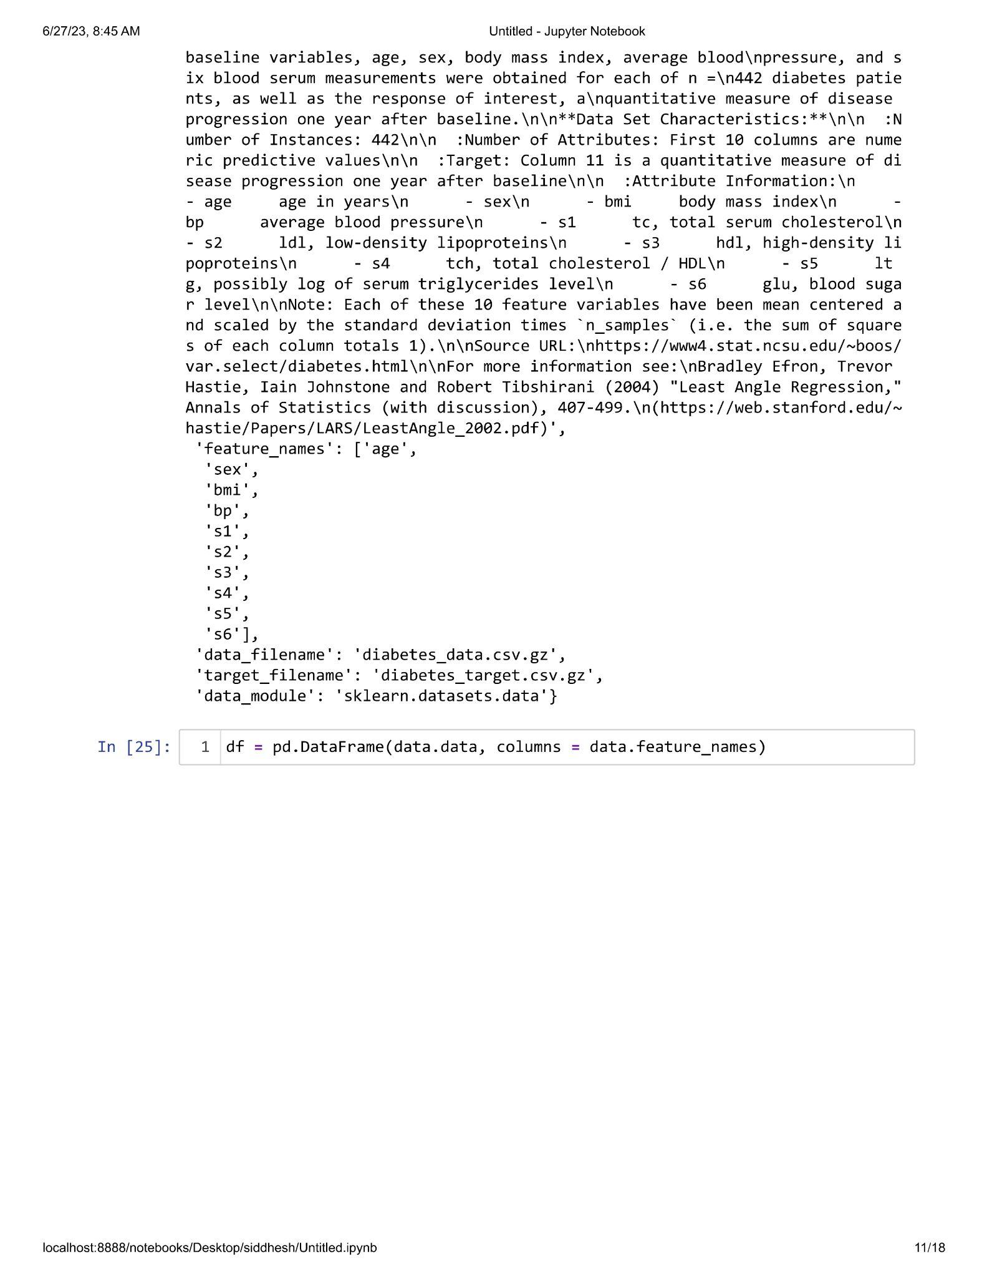

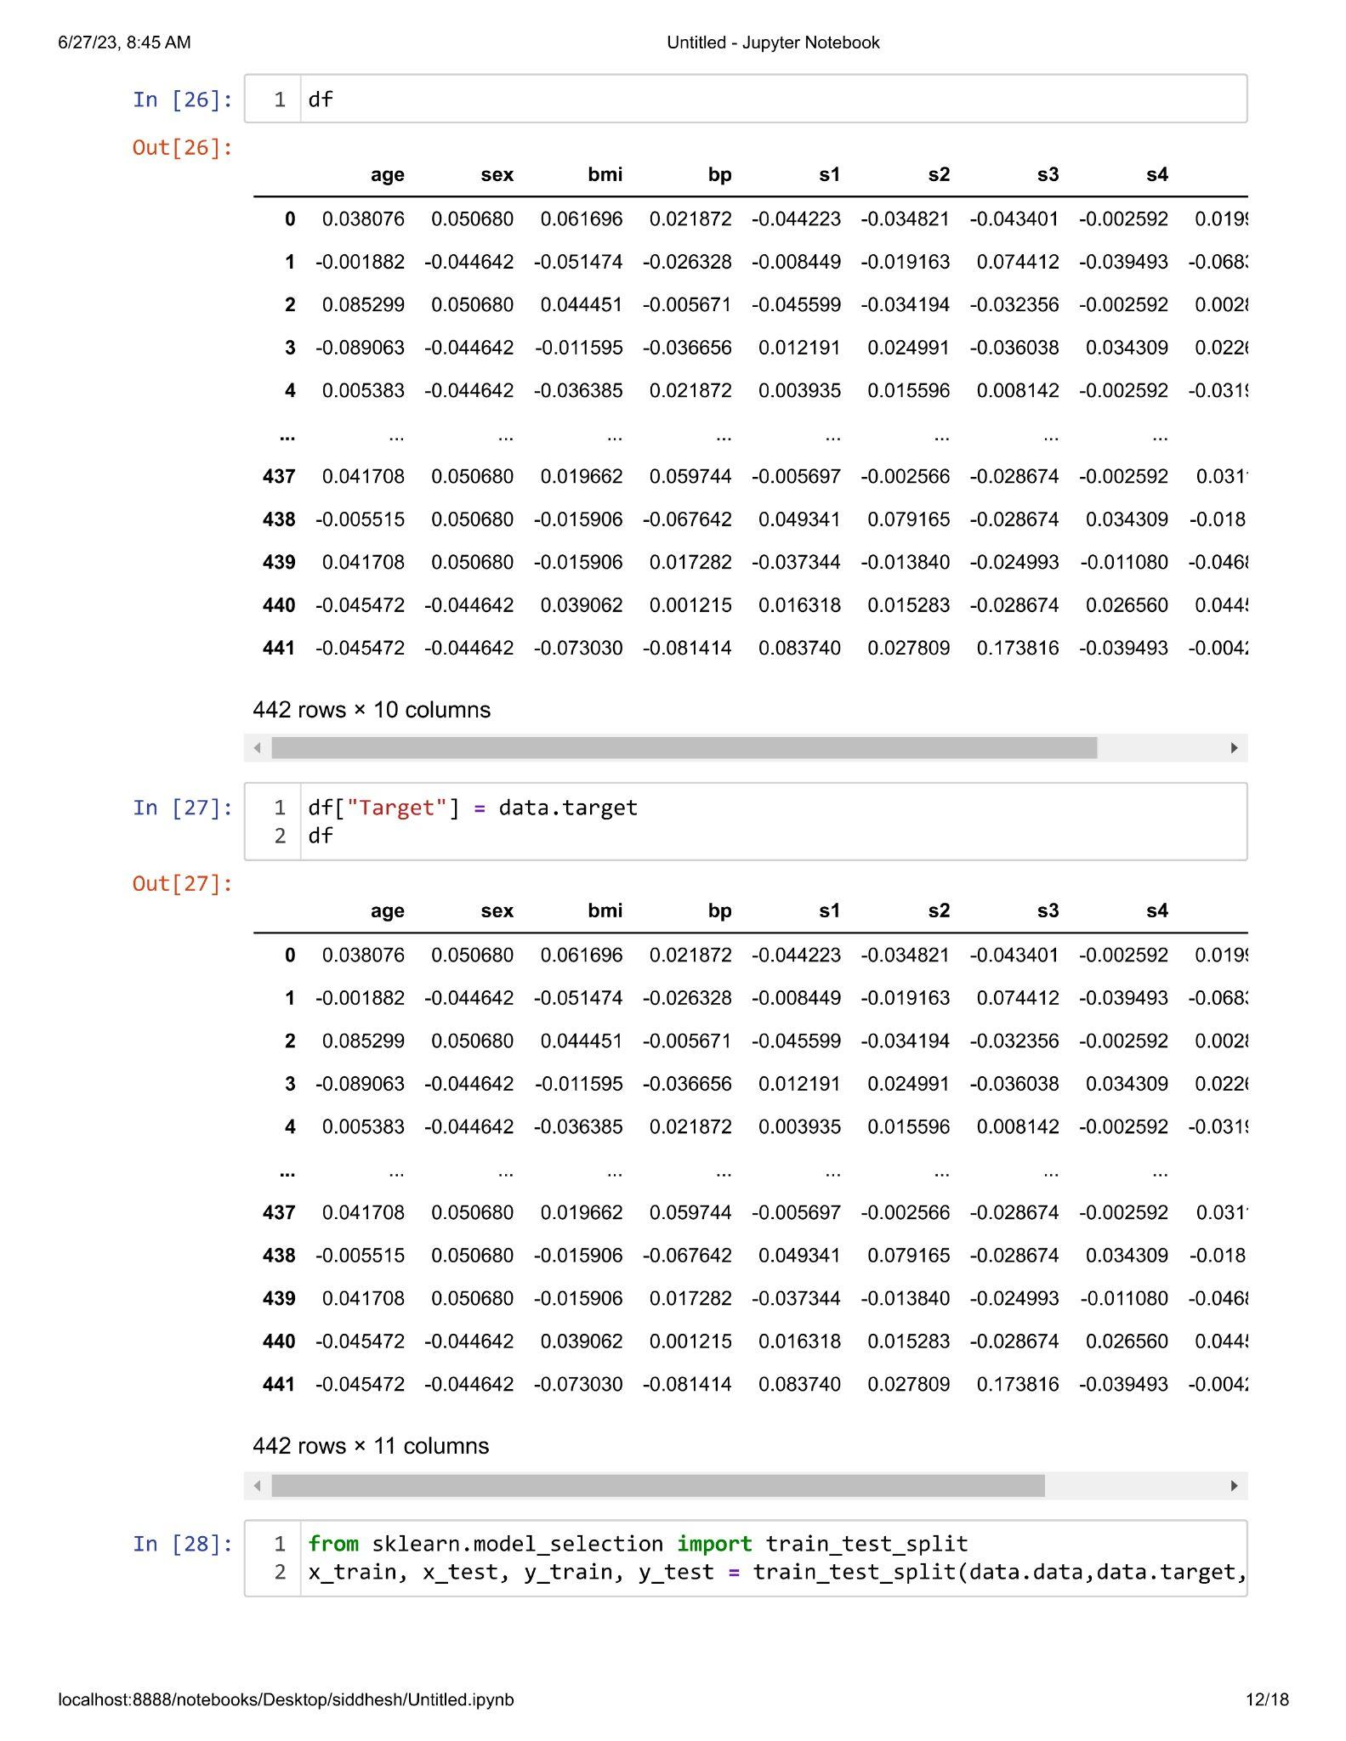

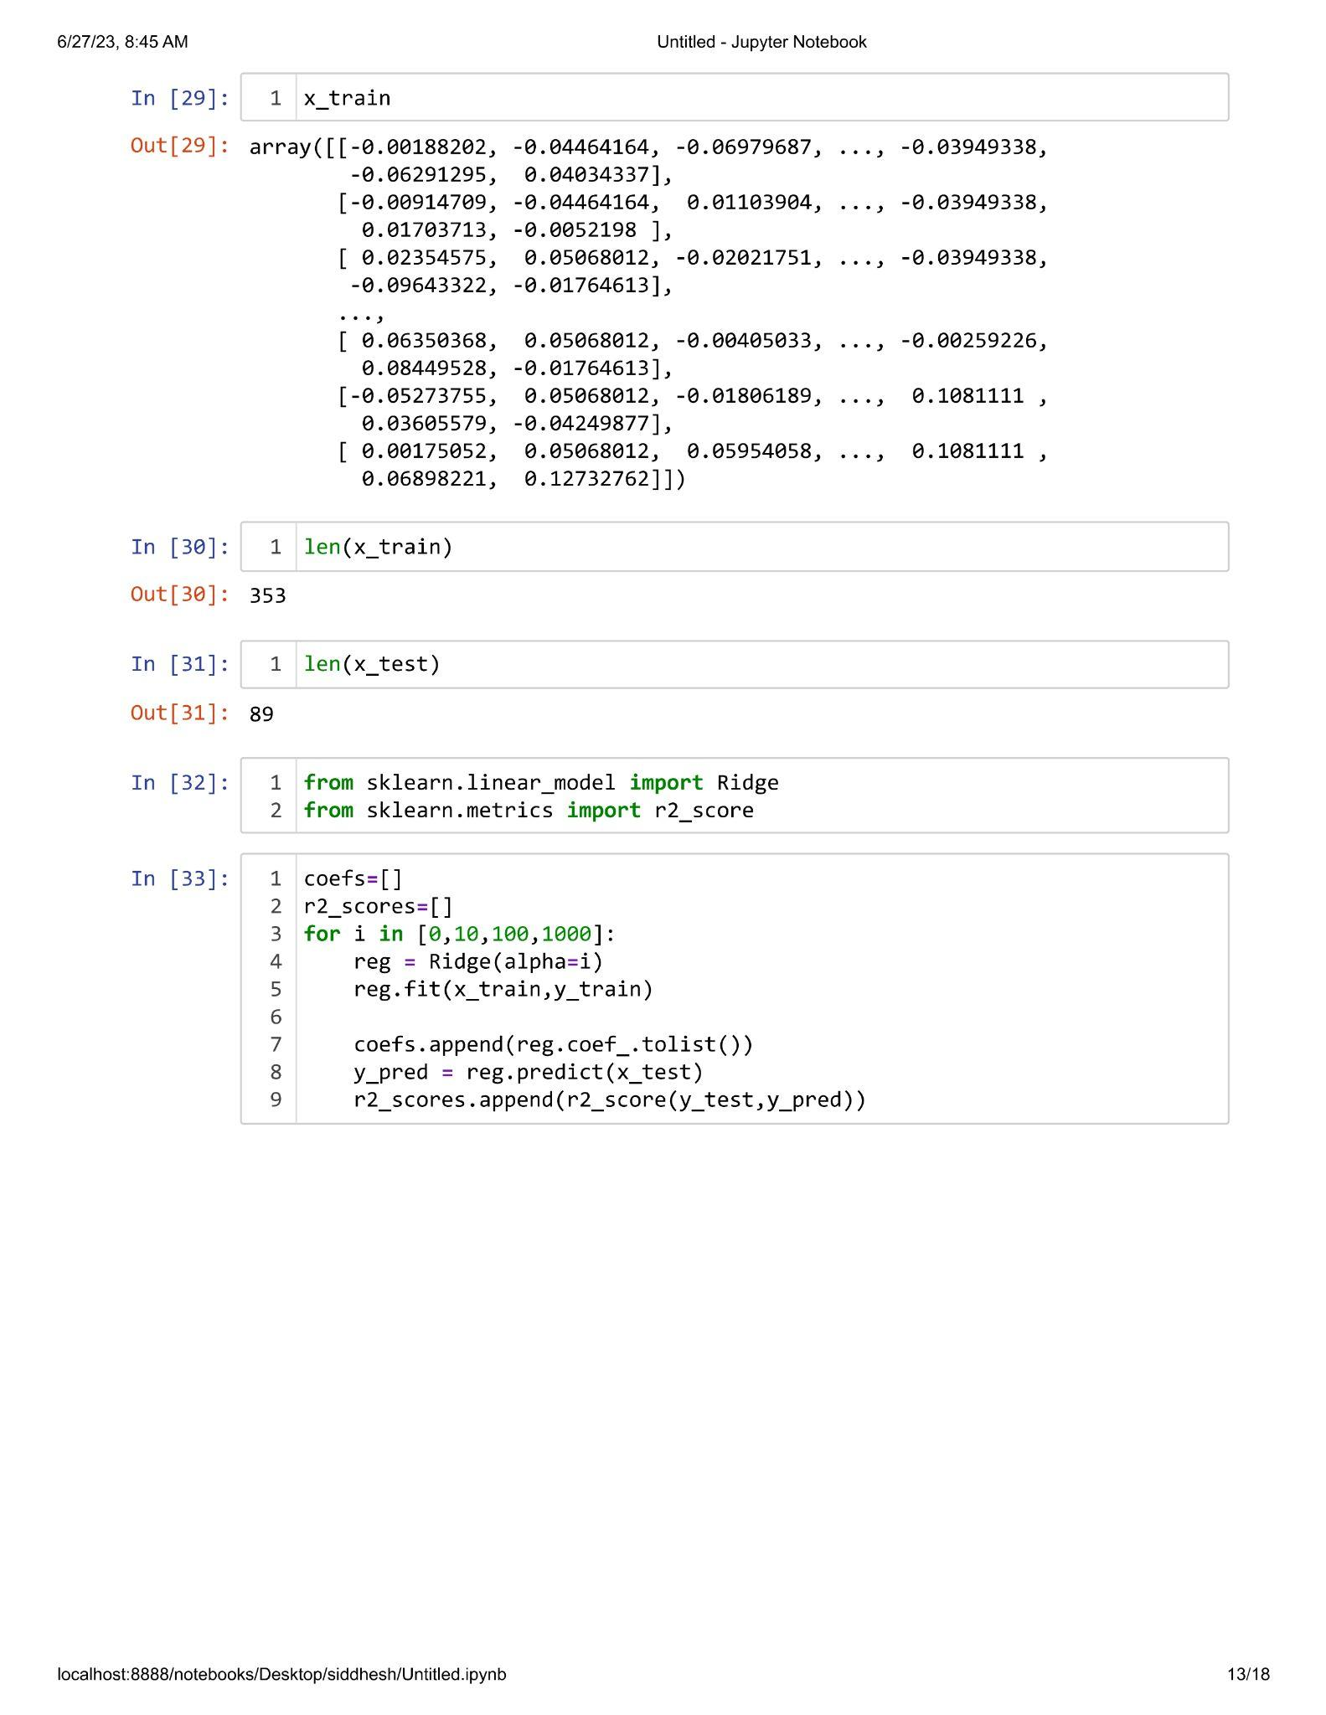

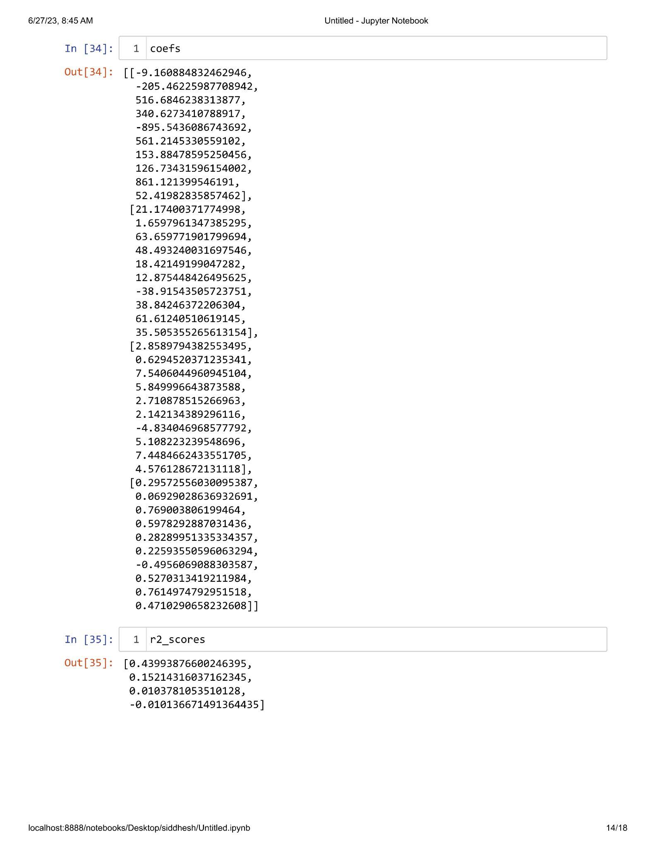

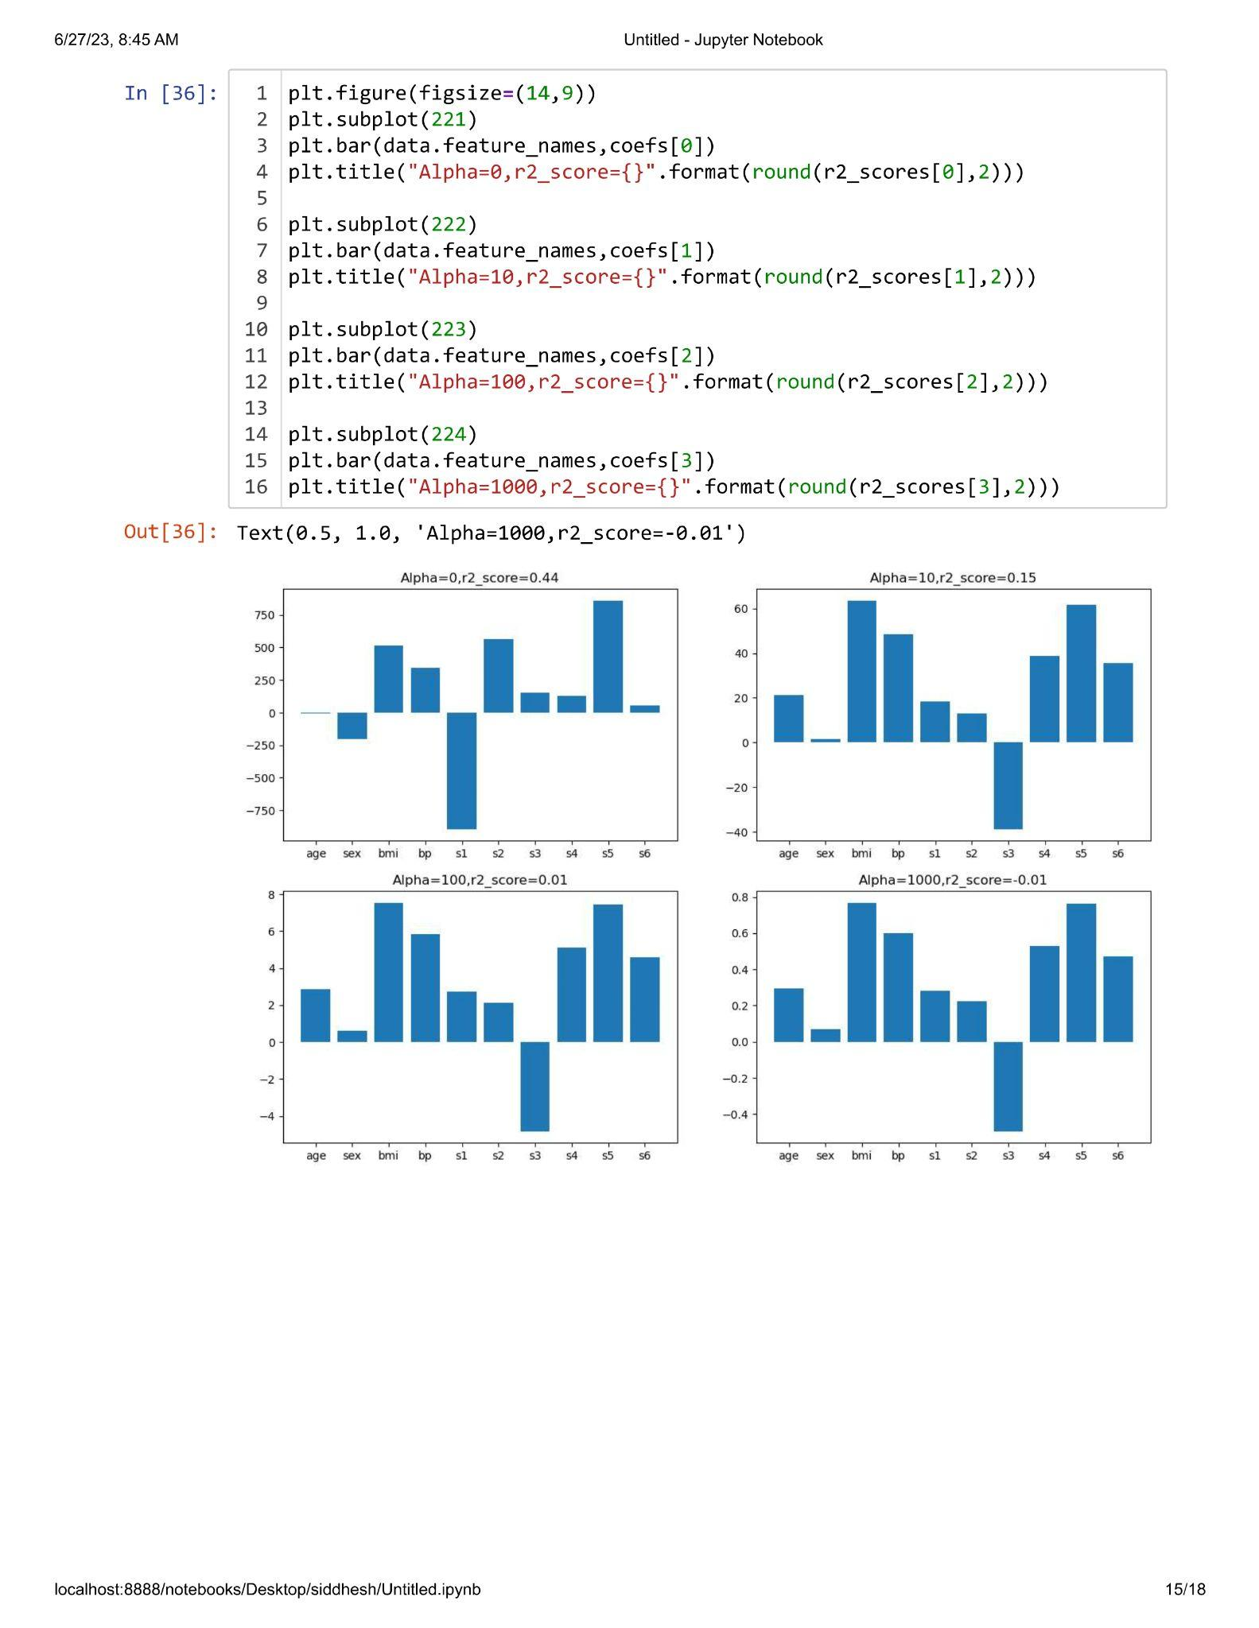

**Practical 2.3**

**Aim : In Ridge Regression prove that 'The more higher co-efficient are affected more'.**

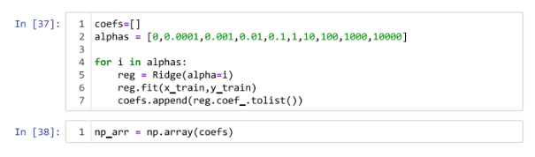

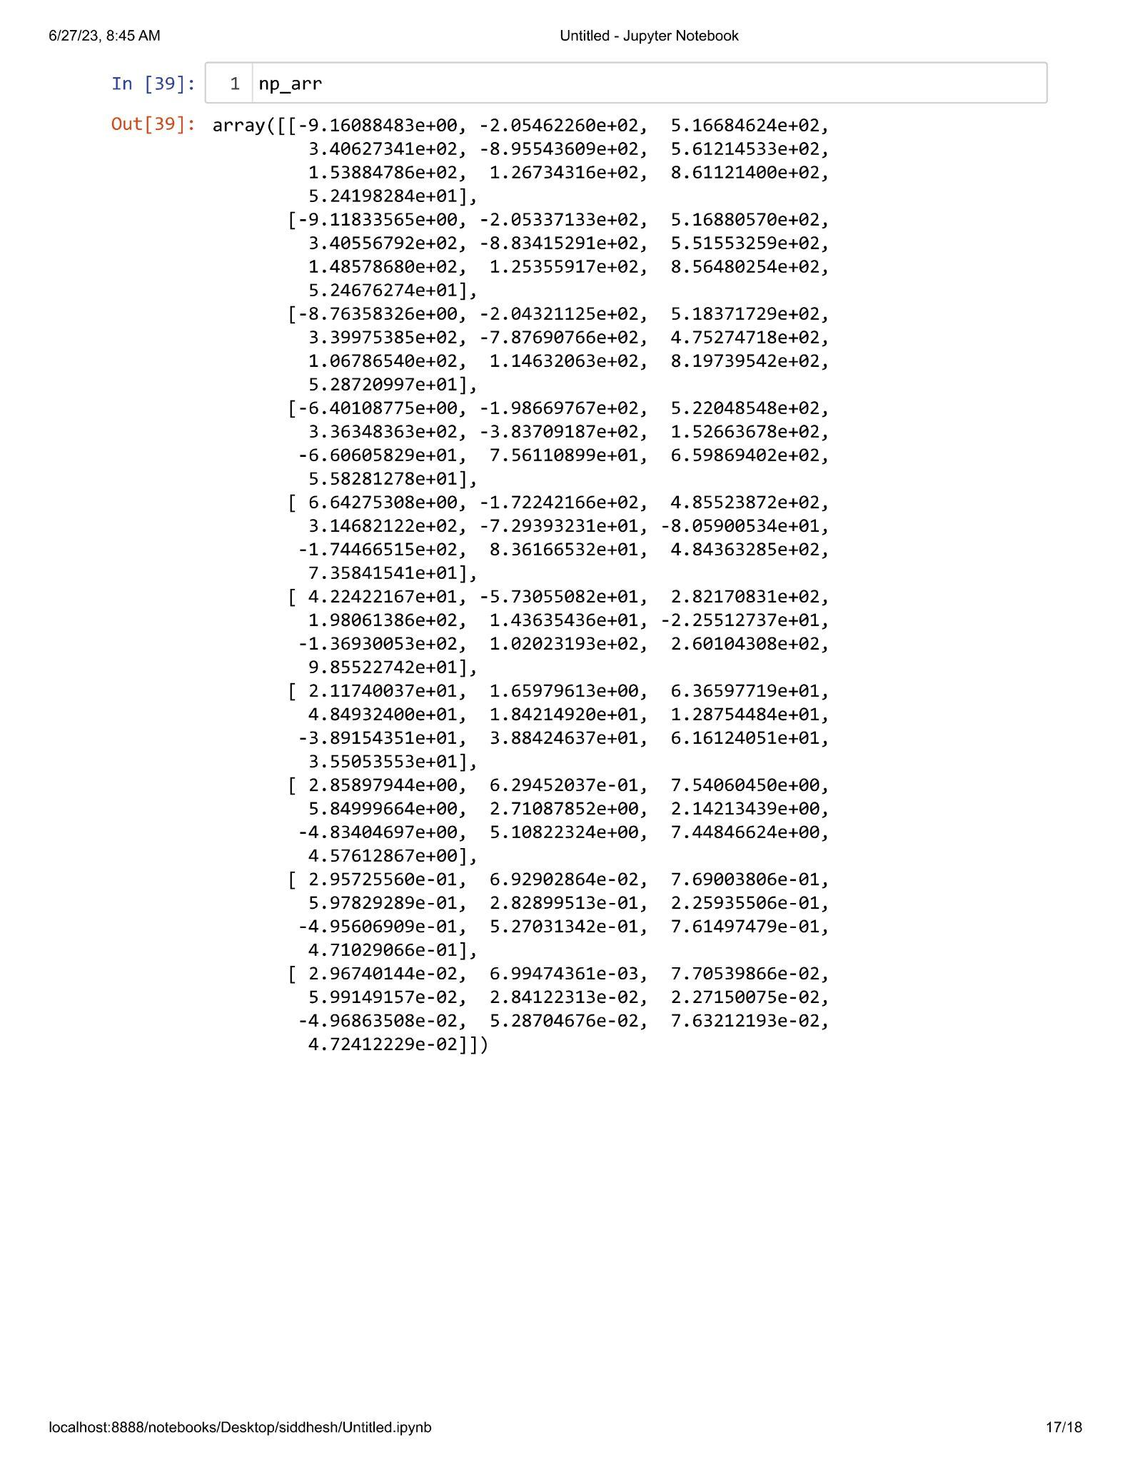

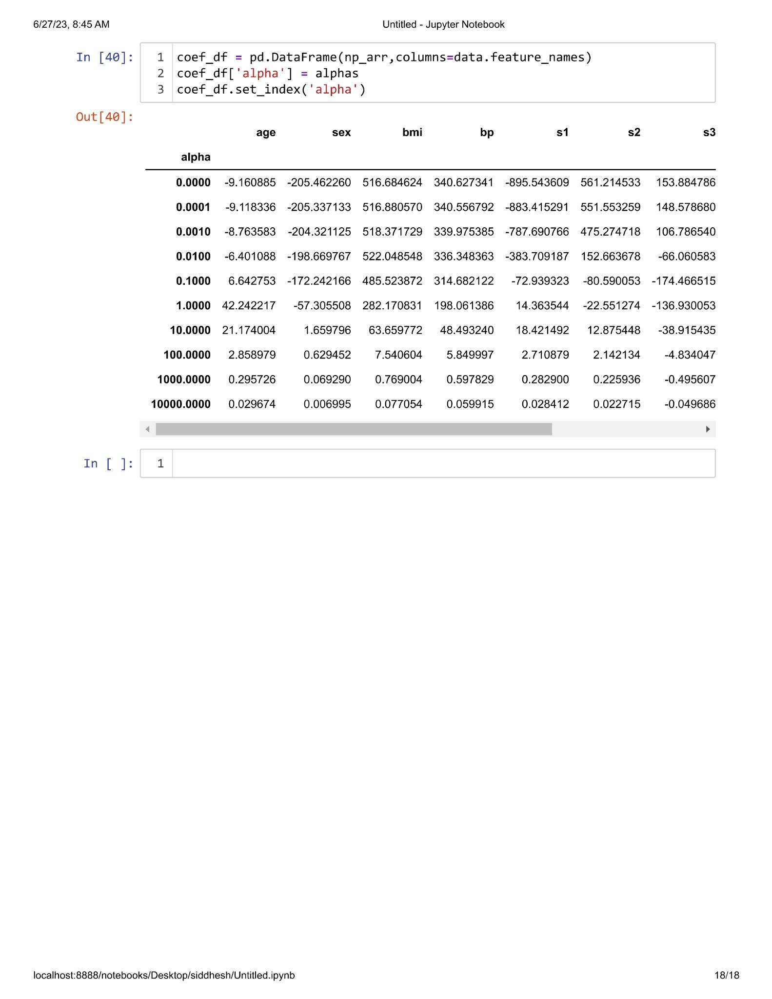

**Practical 2.4**

**Aim : Implementation of LASSO Regression.**

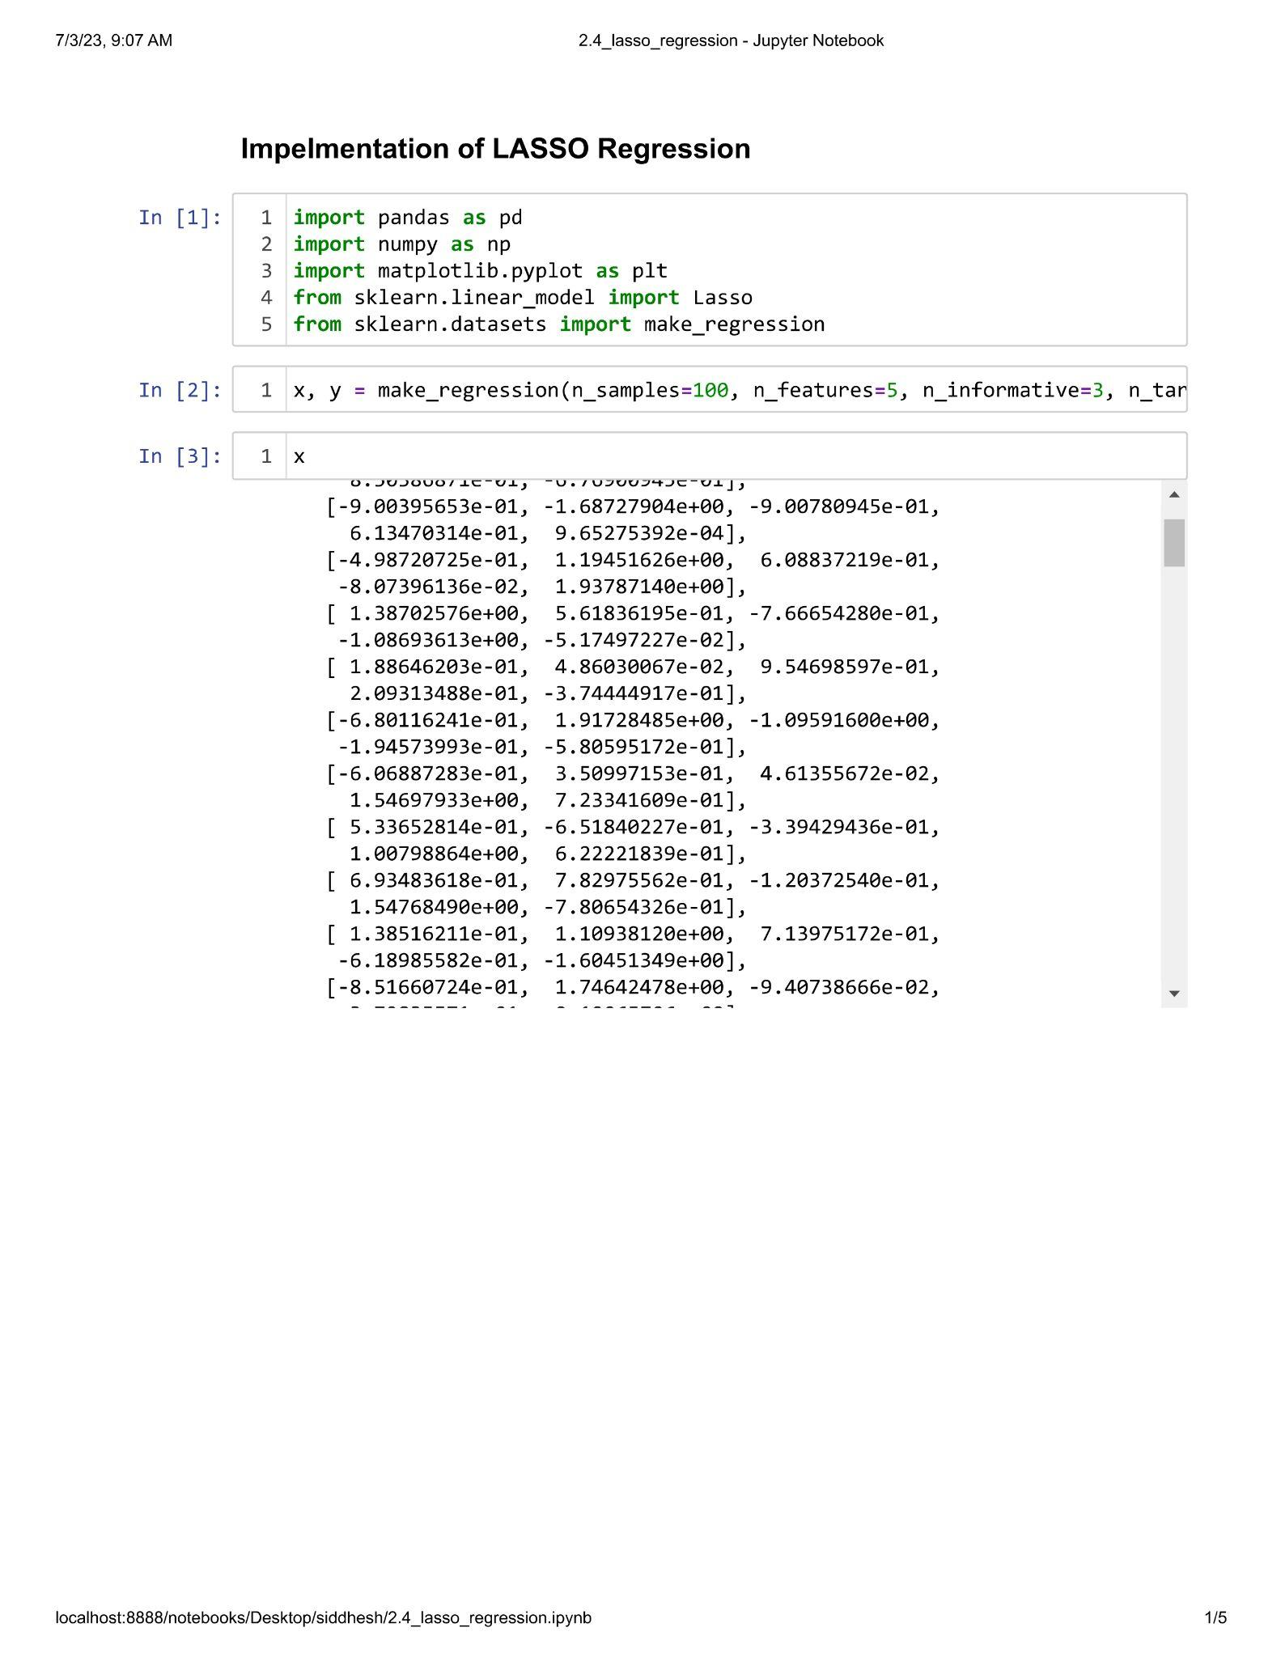

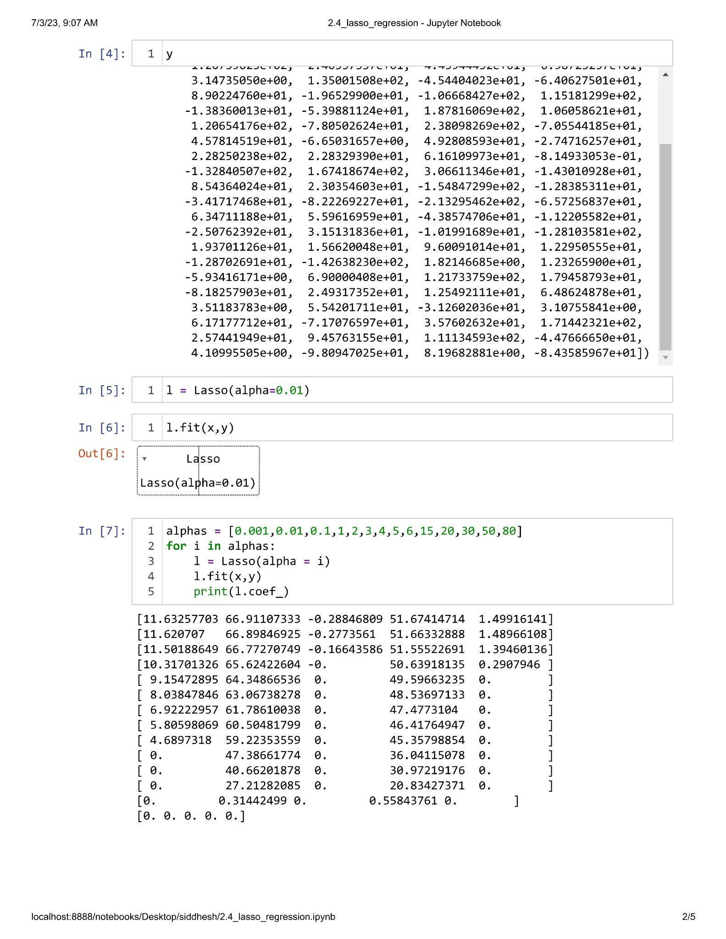

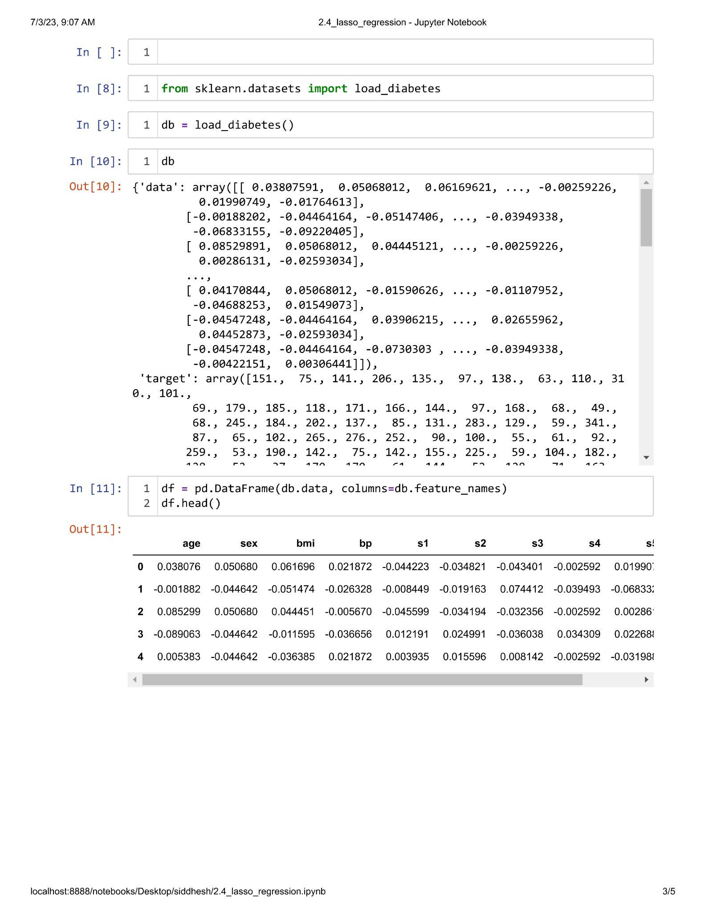

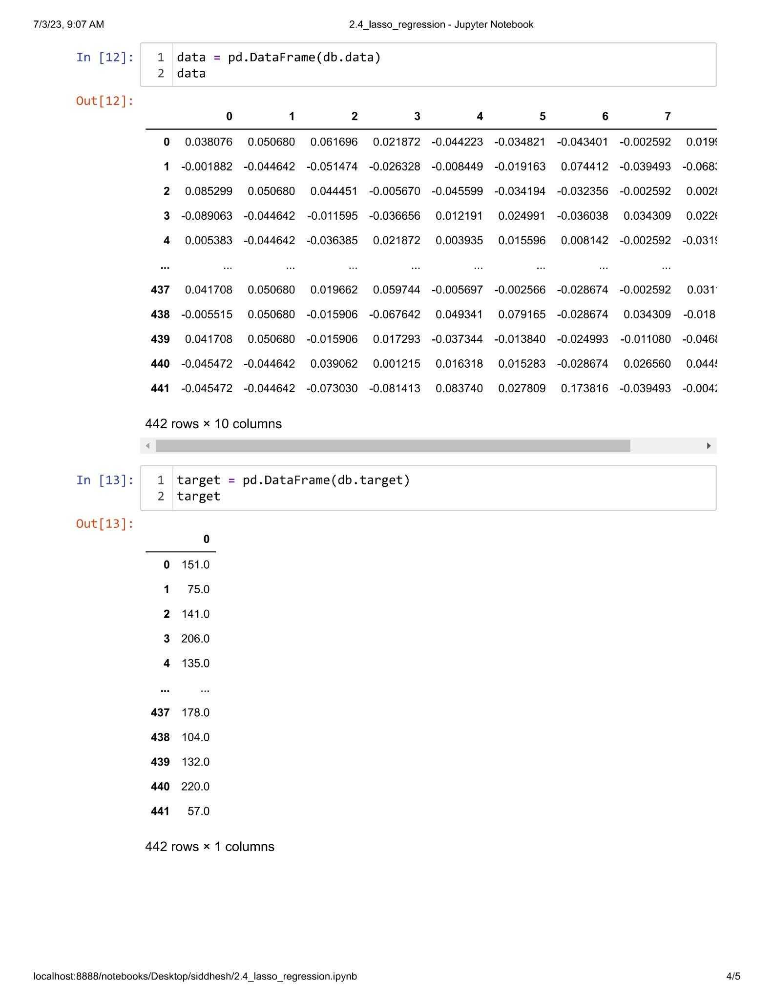

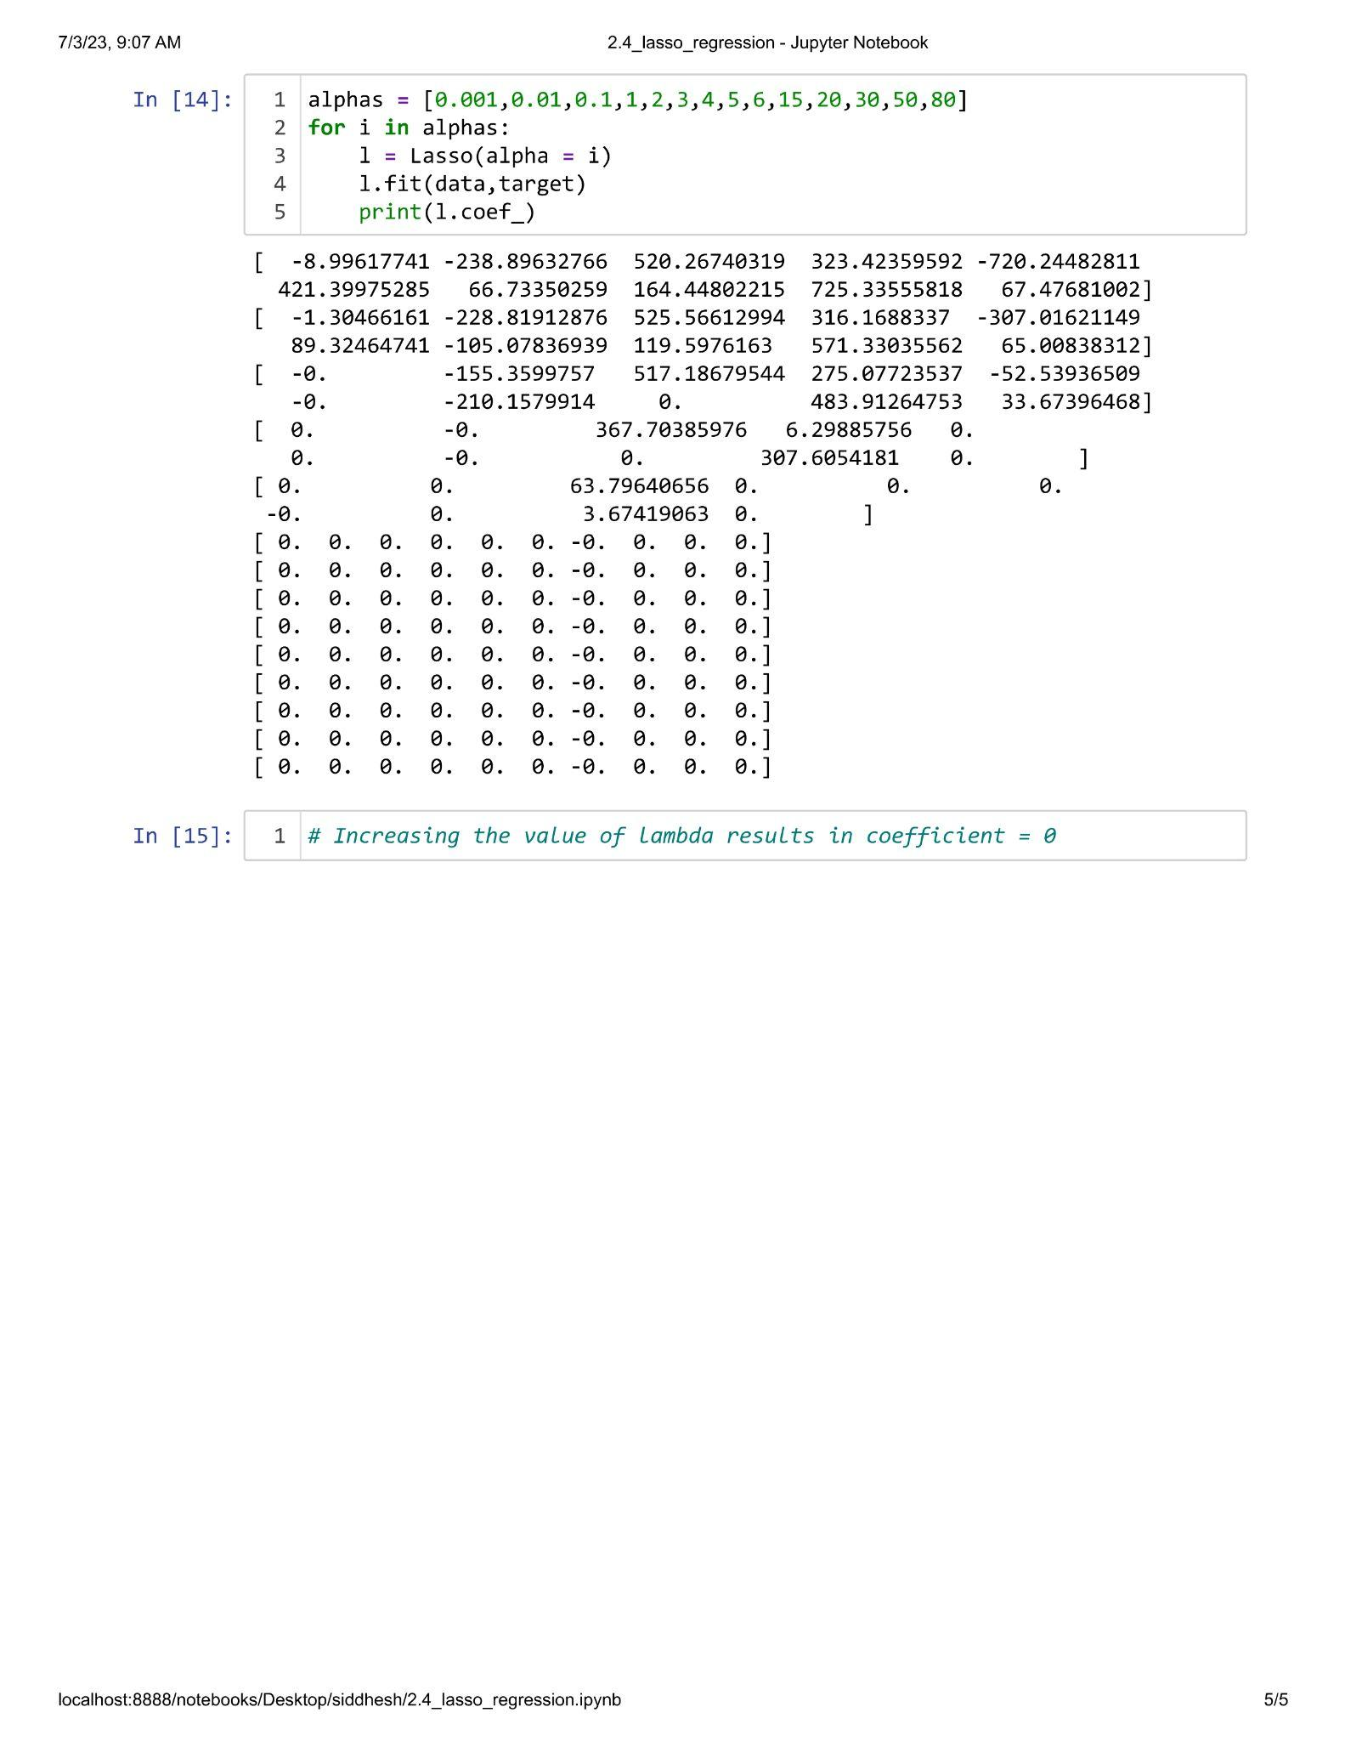

**Unit III**

**Practical 3.1**

**Aim : Implementation of Voting Ensemble Learning.**

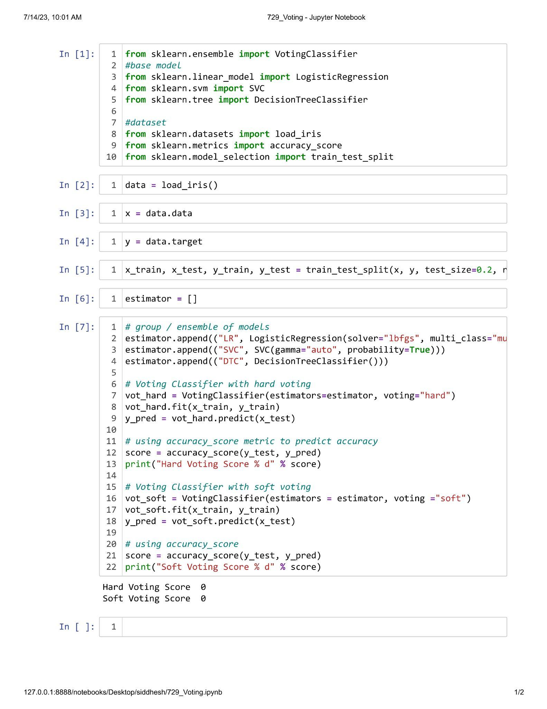

**Practical 3.2**

**Aim : Implementation of Bagging Technique.**

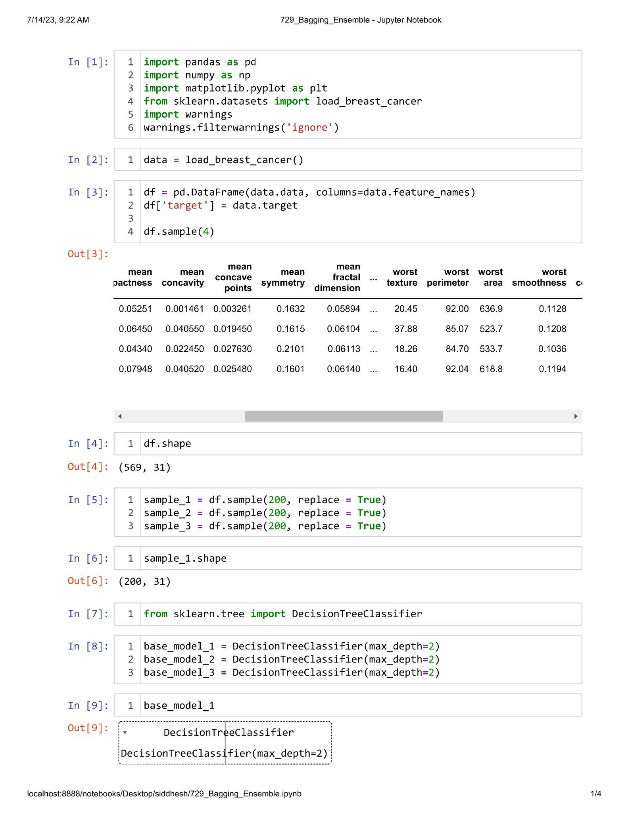

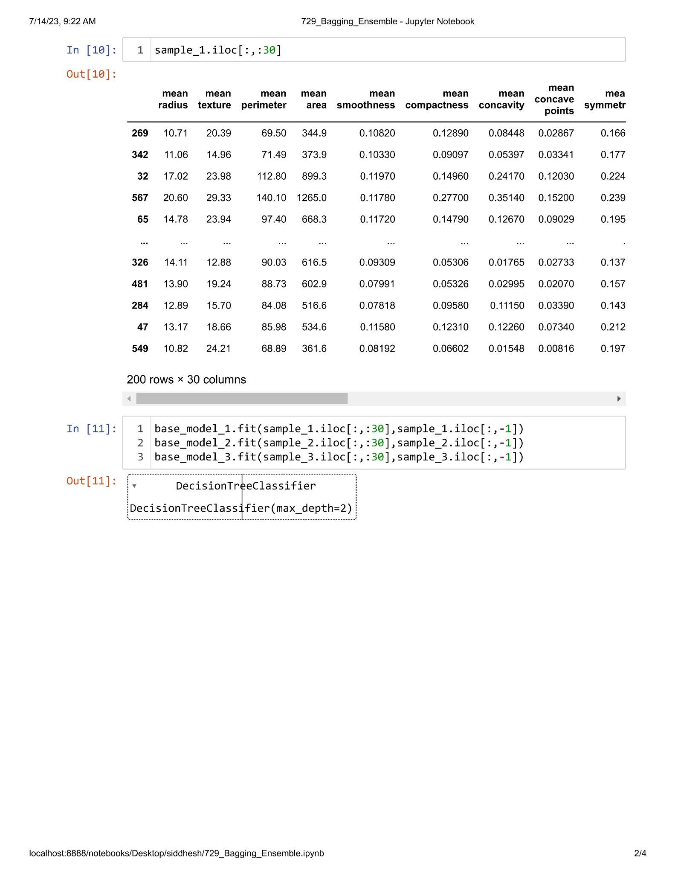

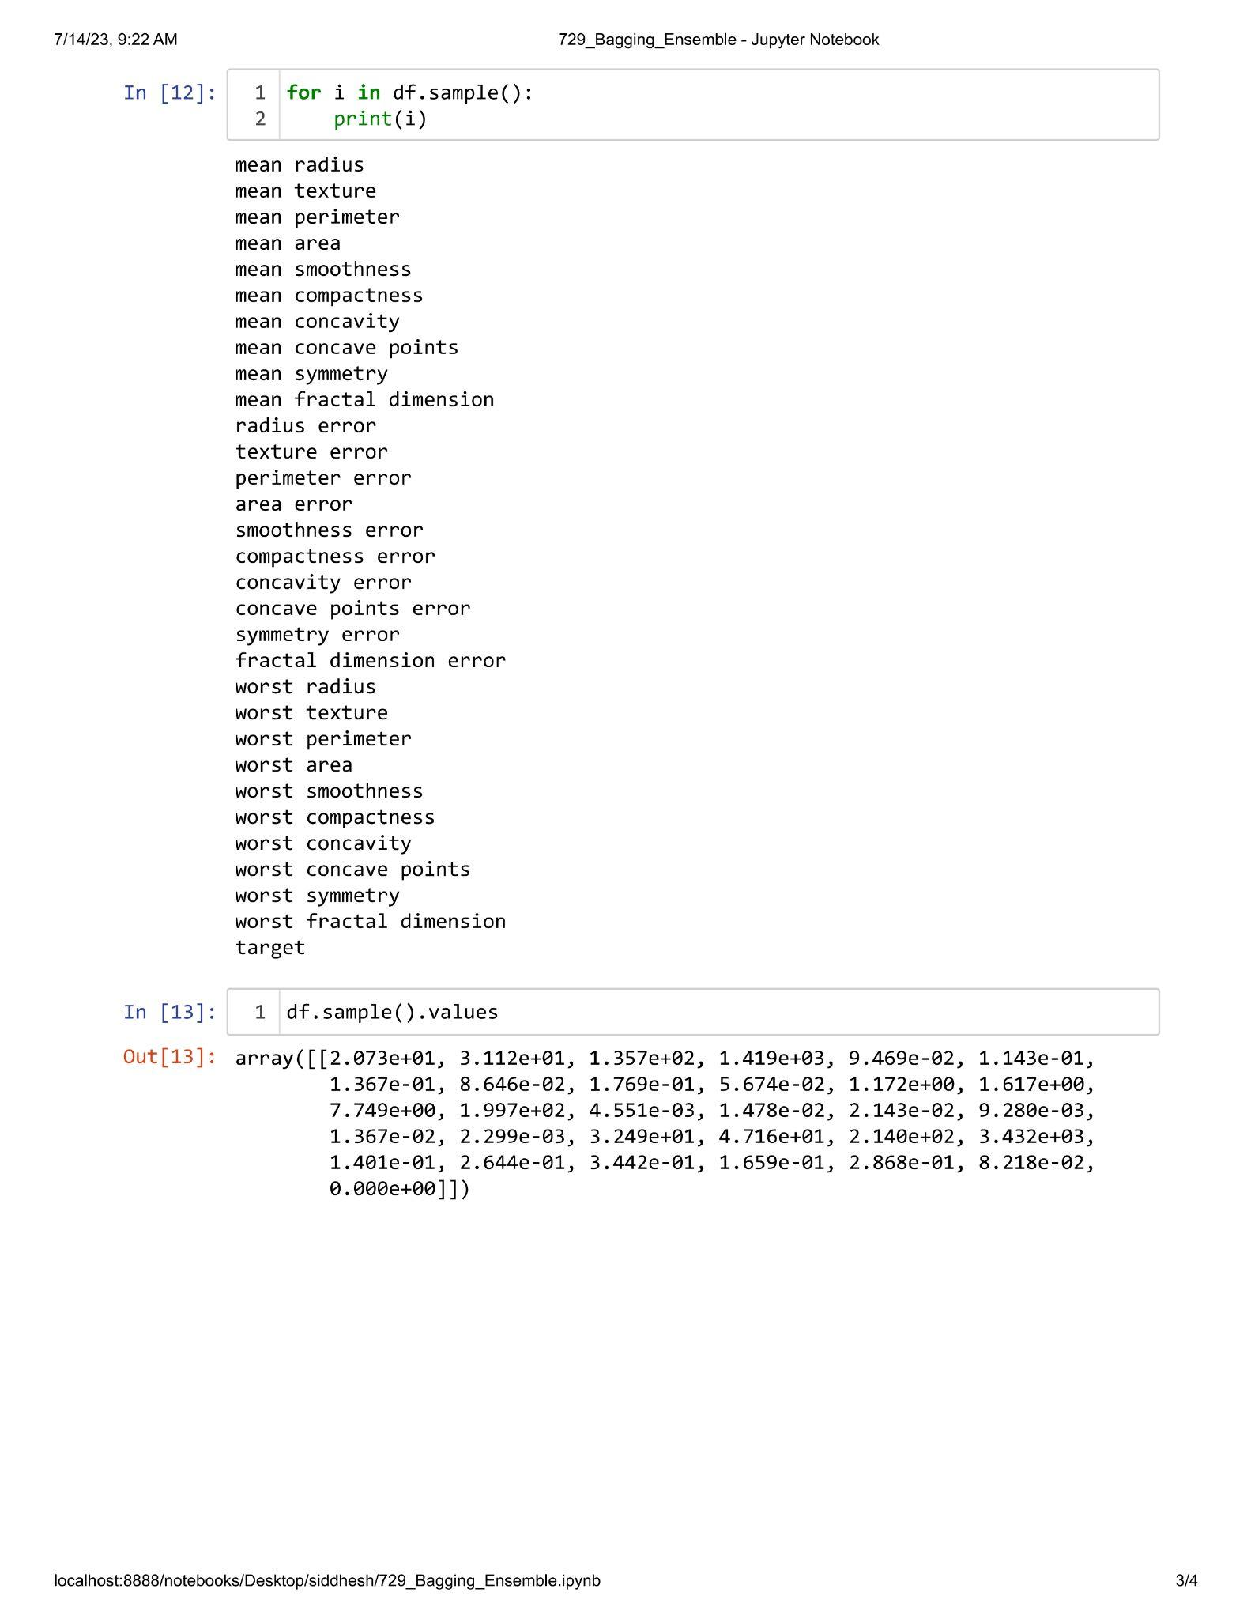

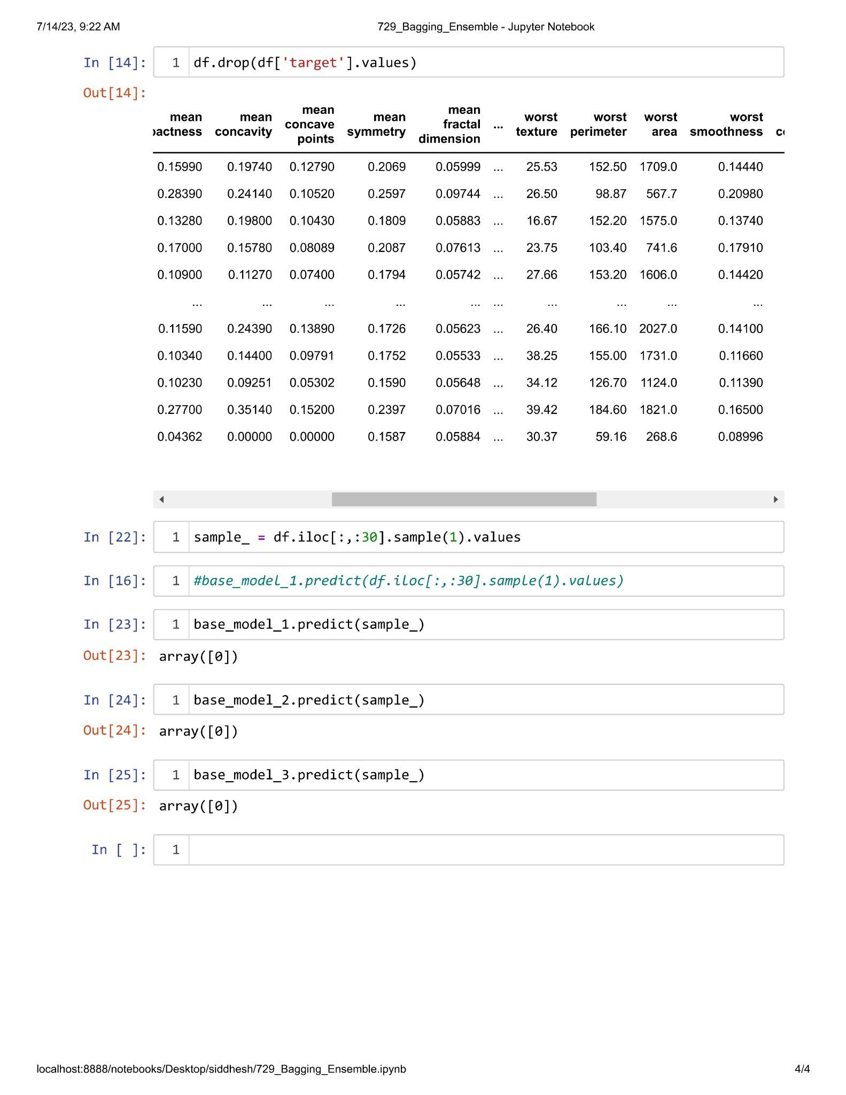

**Practical 3.3**

**Aim : Implementation of Gradient Boosting Algorithm.**

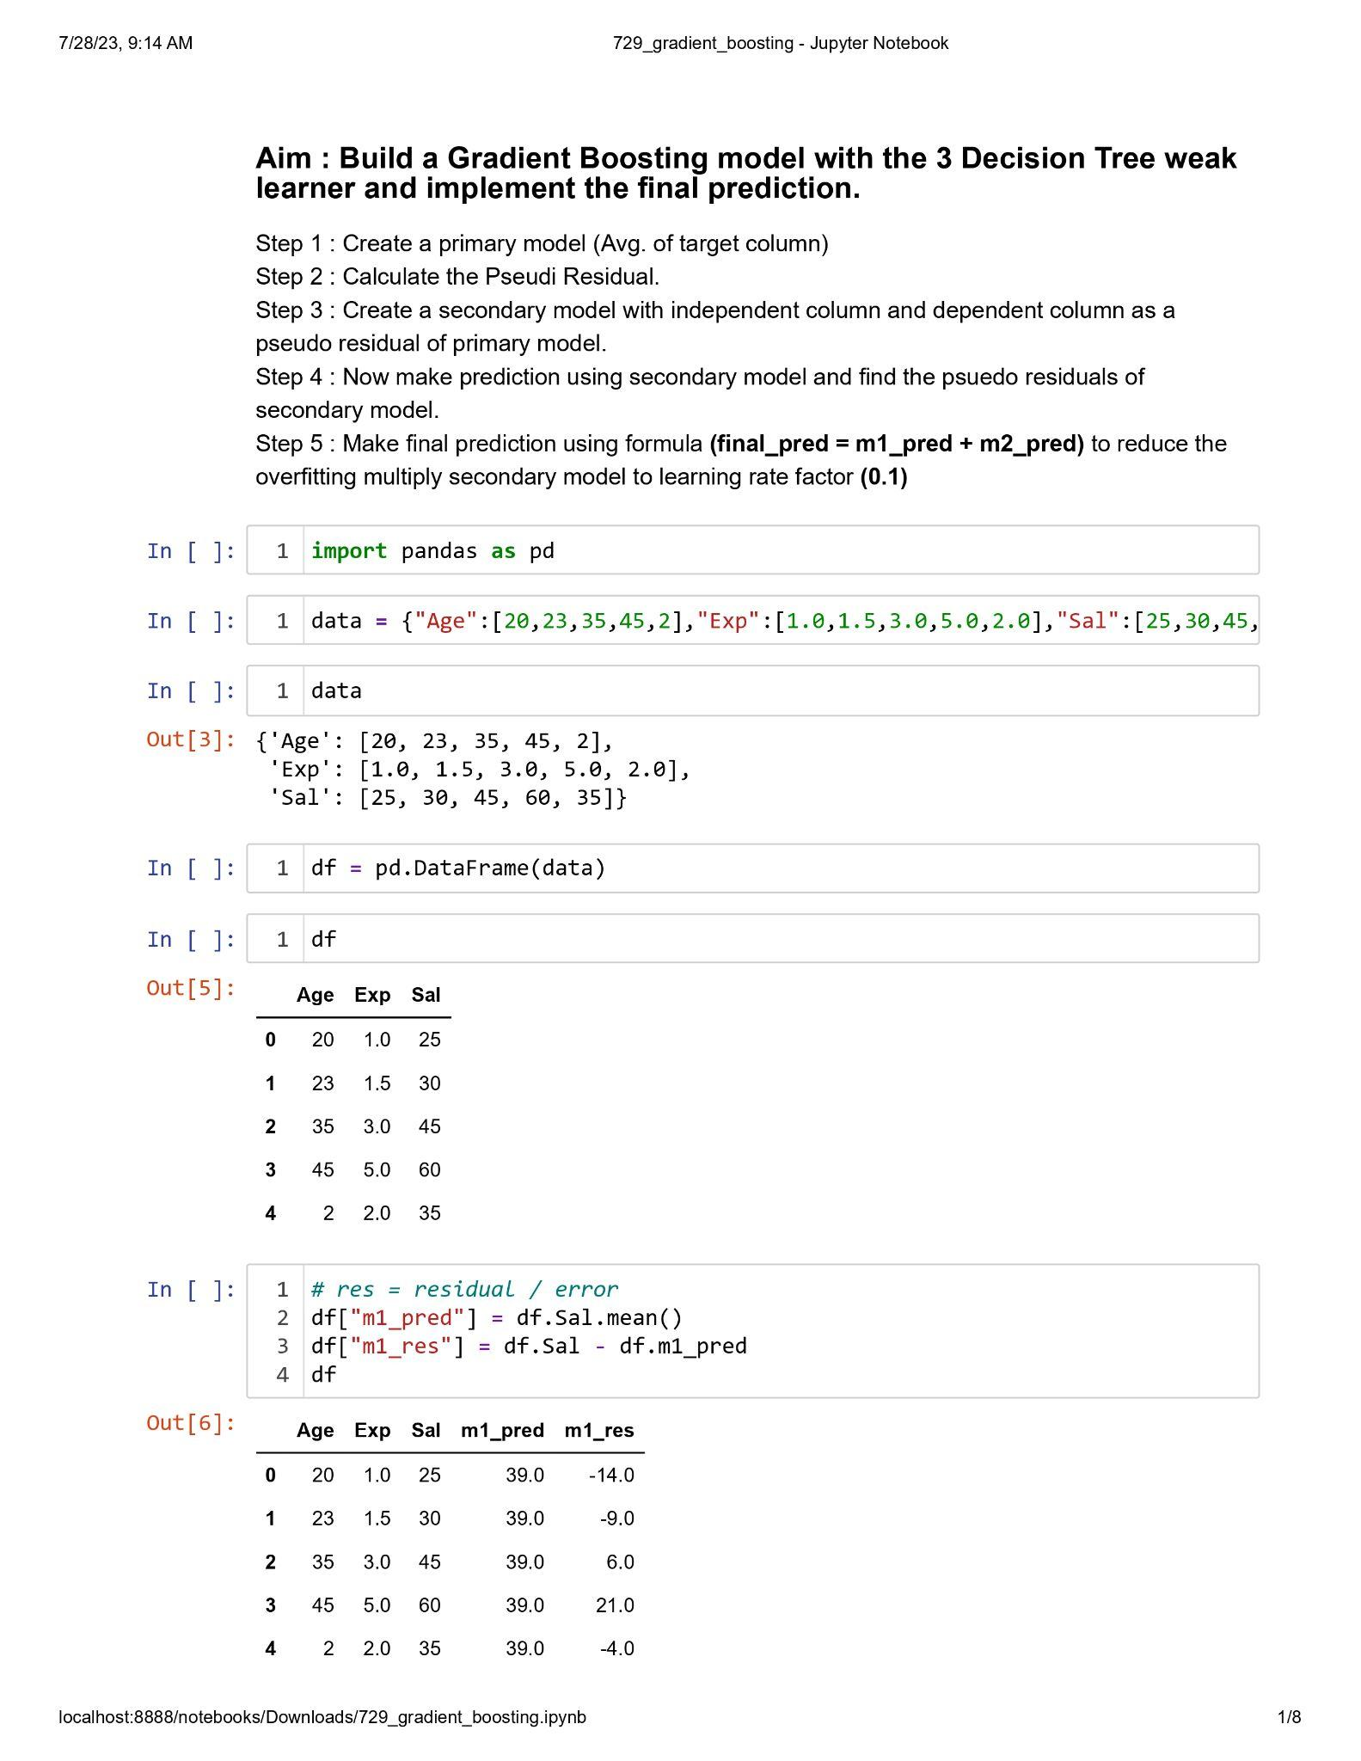

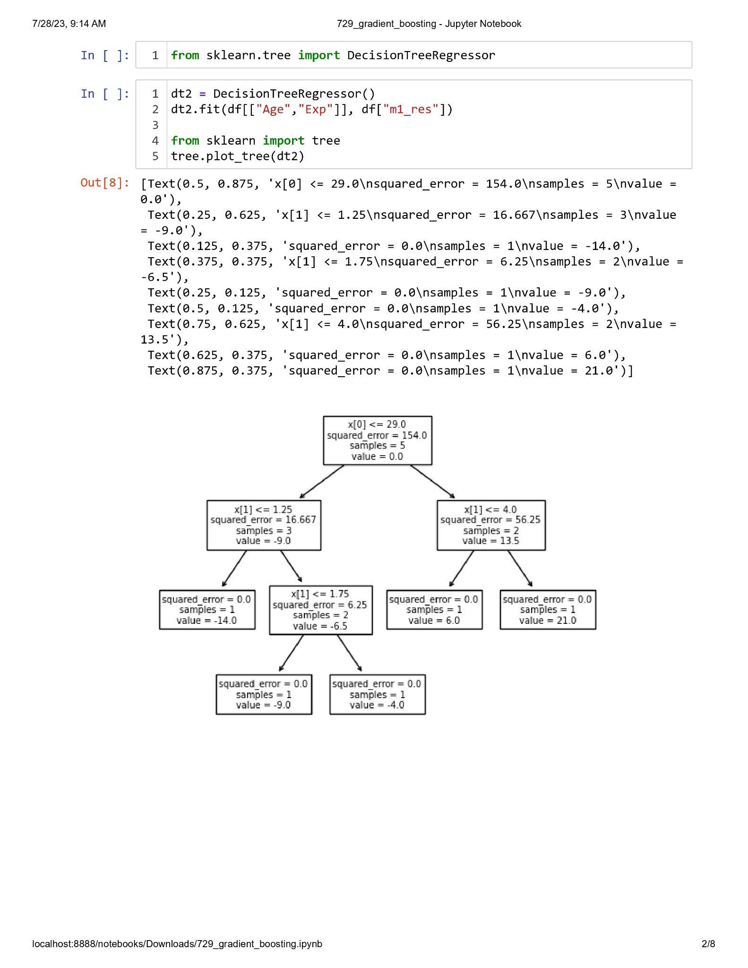

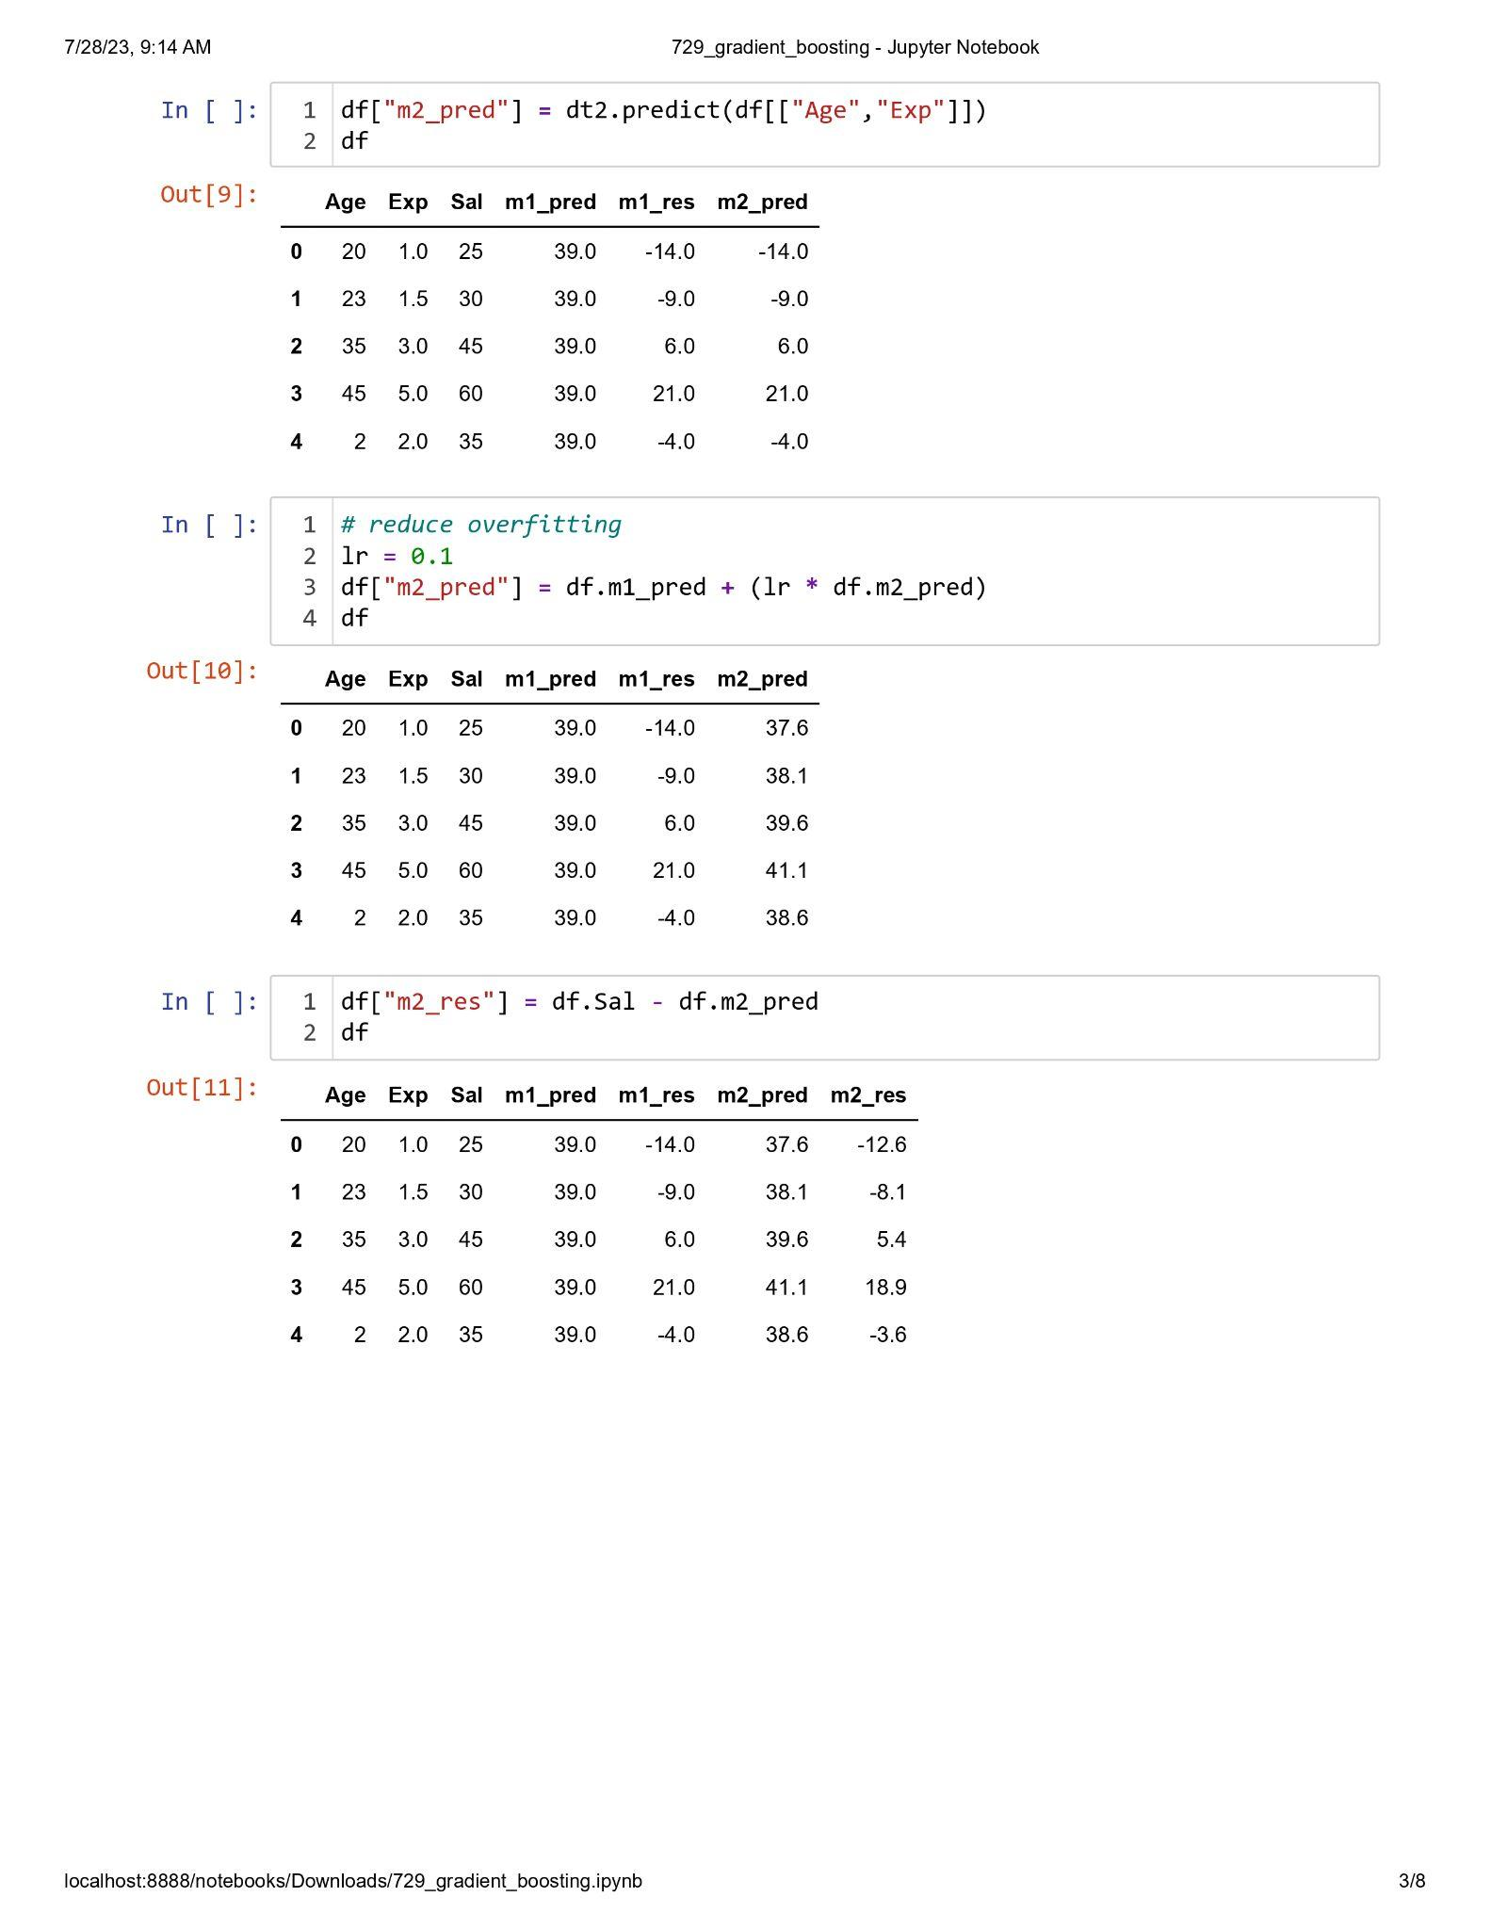

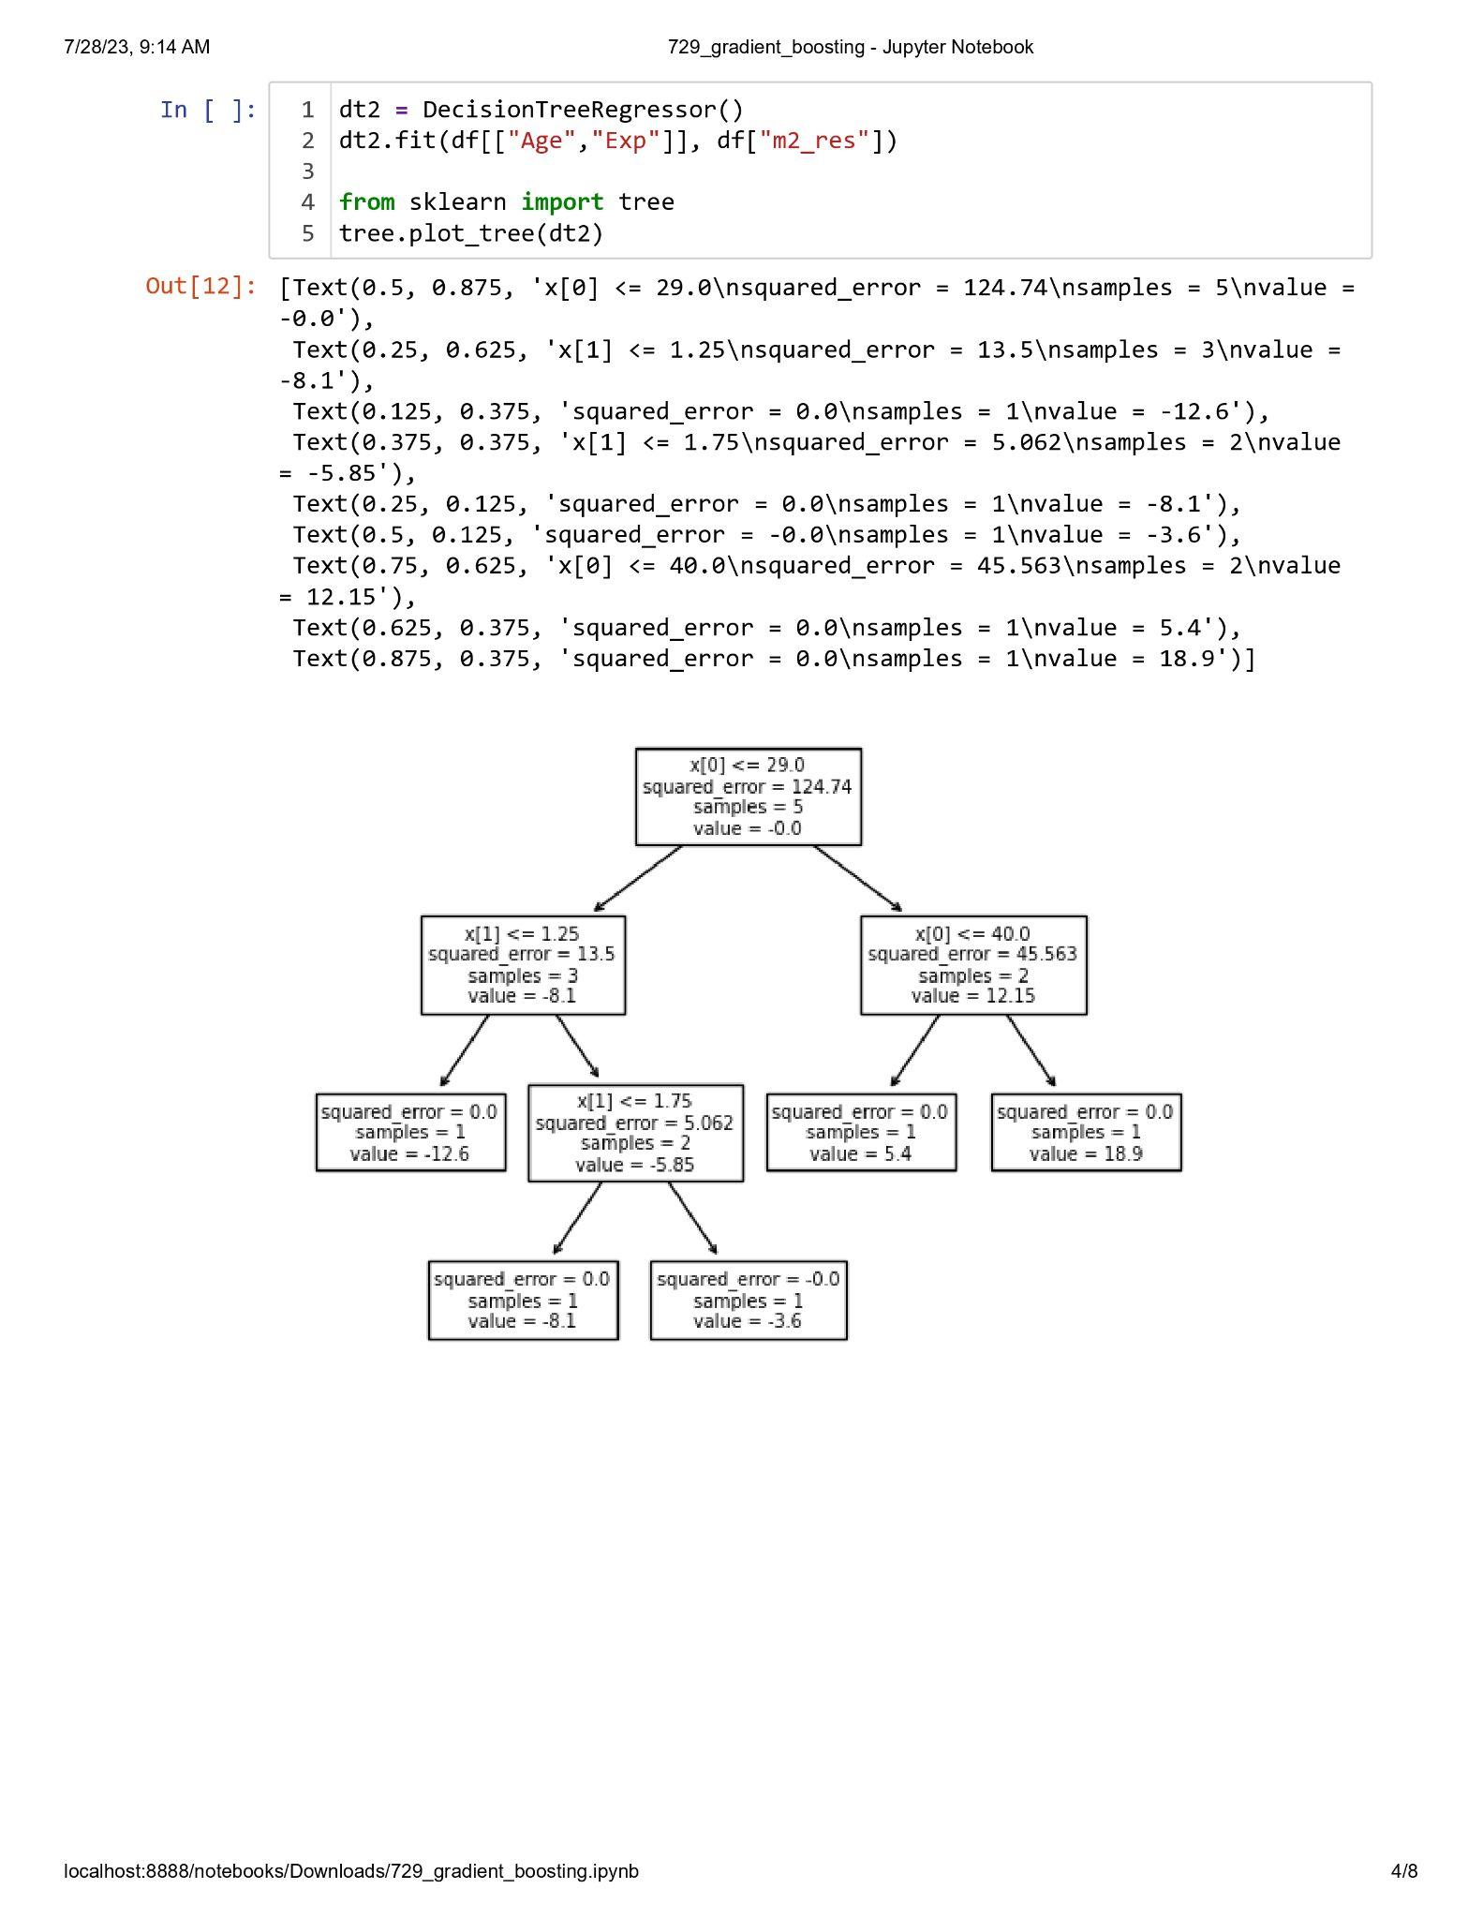

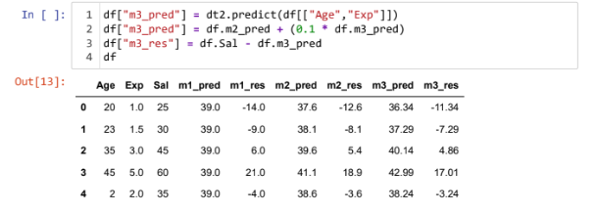

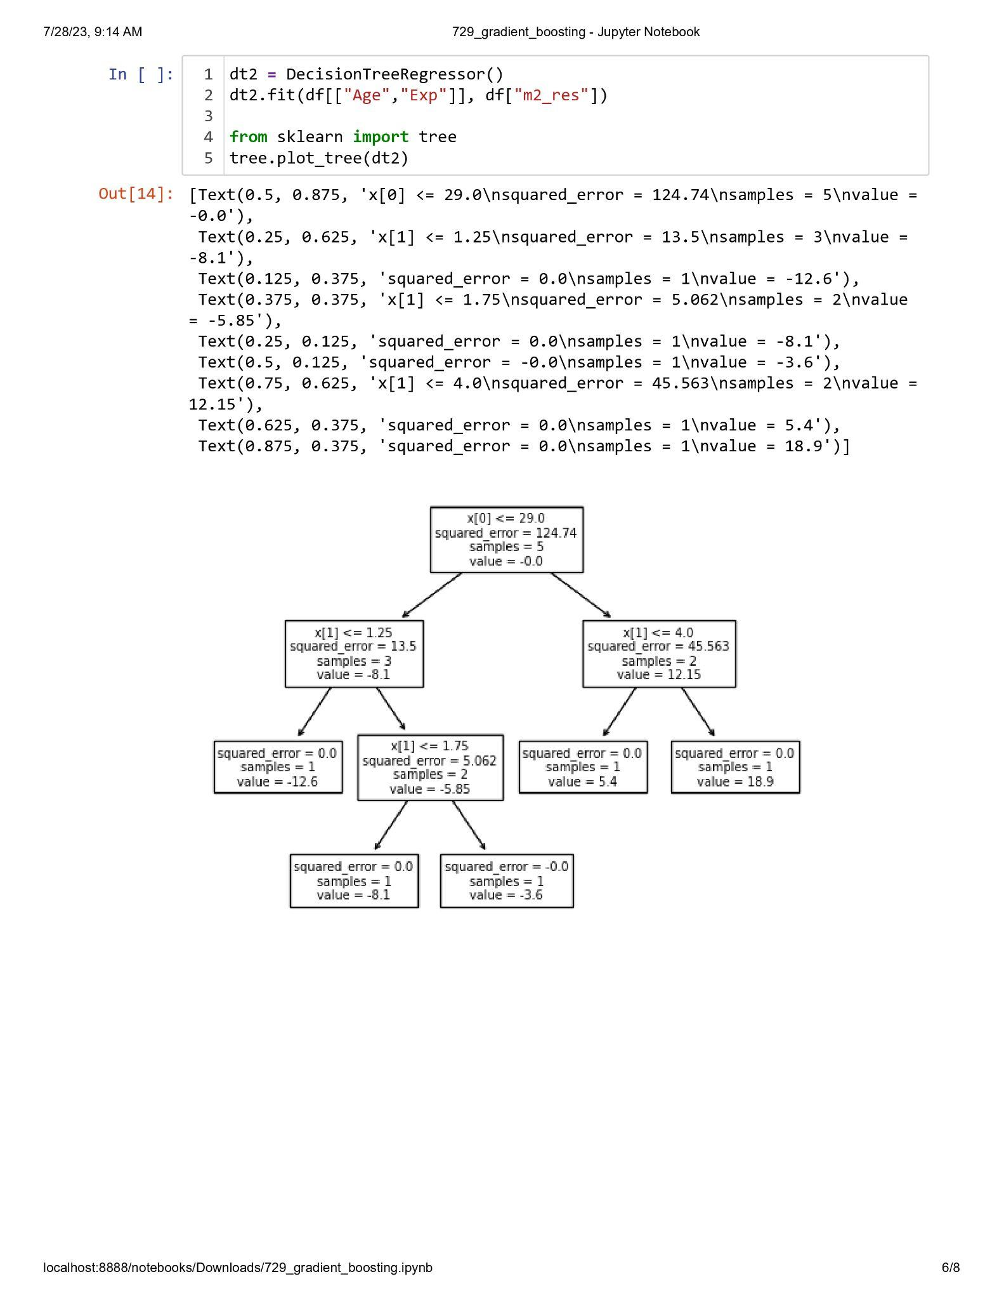

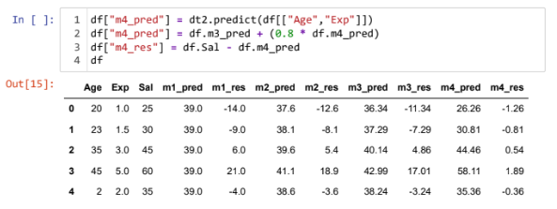

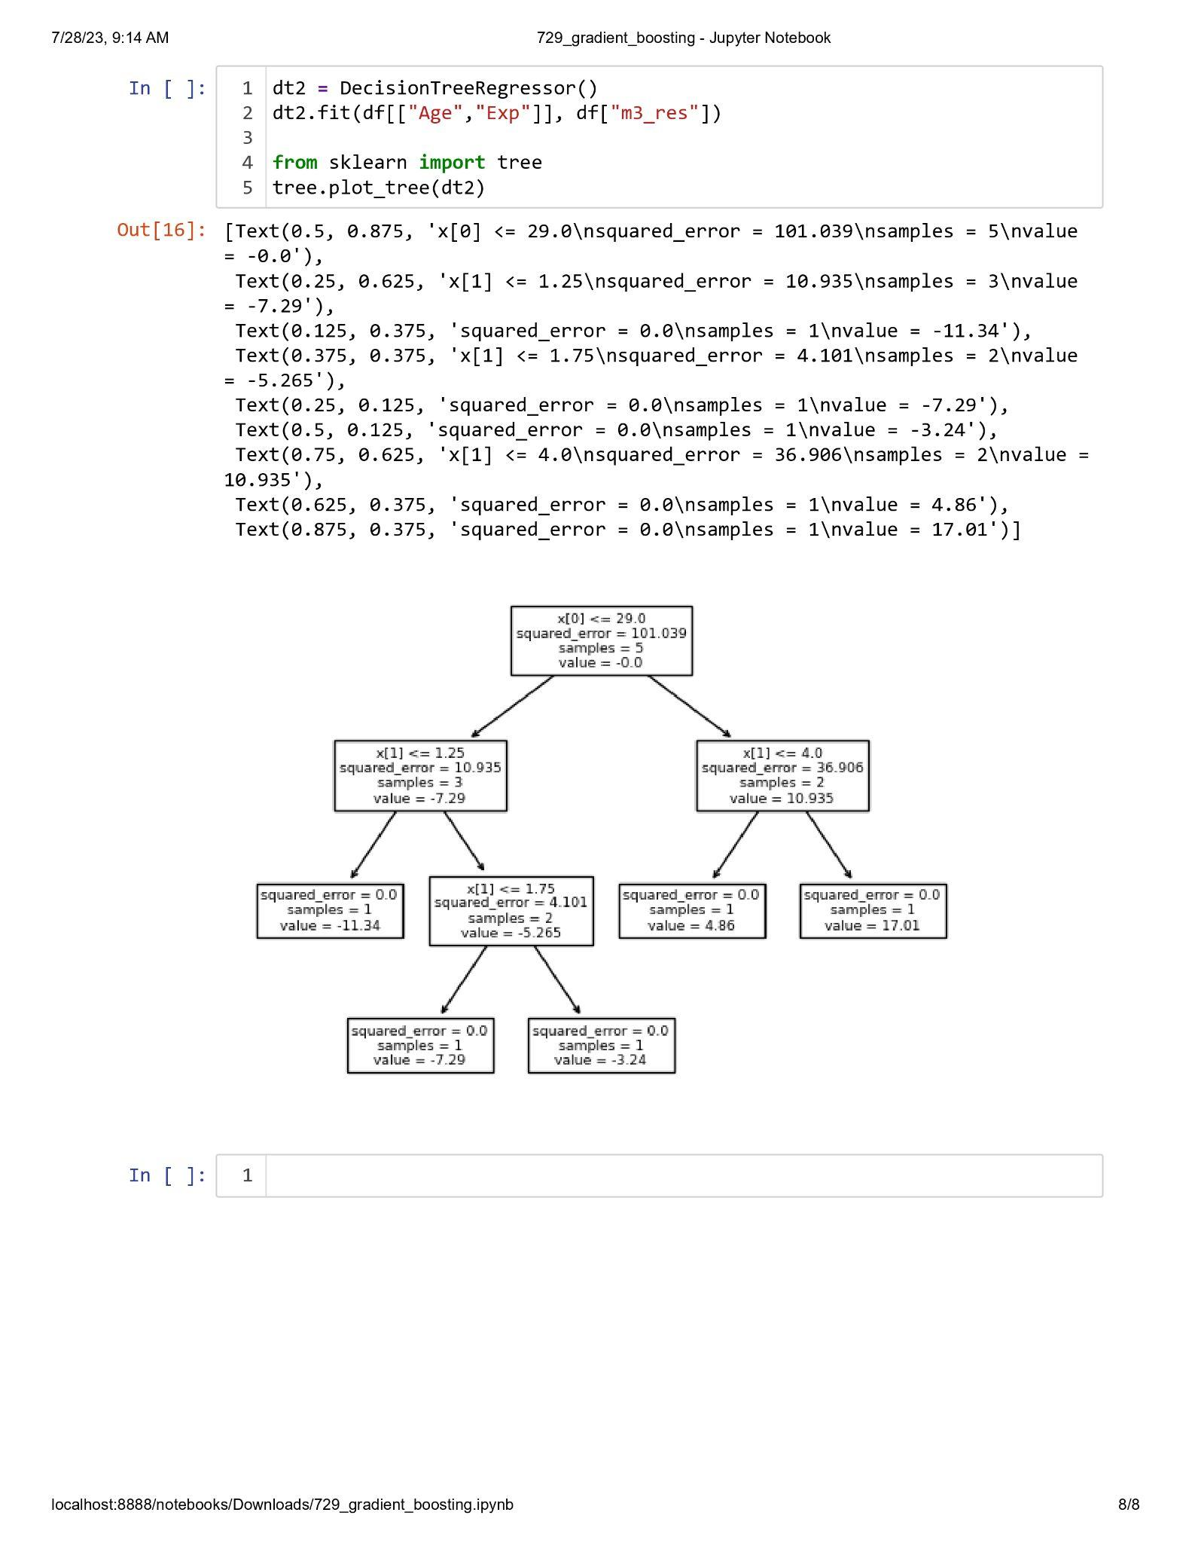

**Practical 3.4**

**Aim : Implementation of Stacking.**

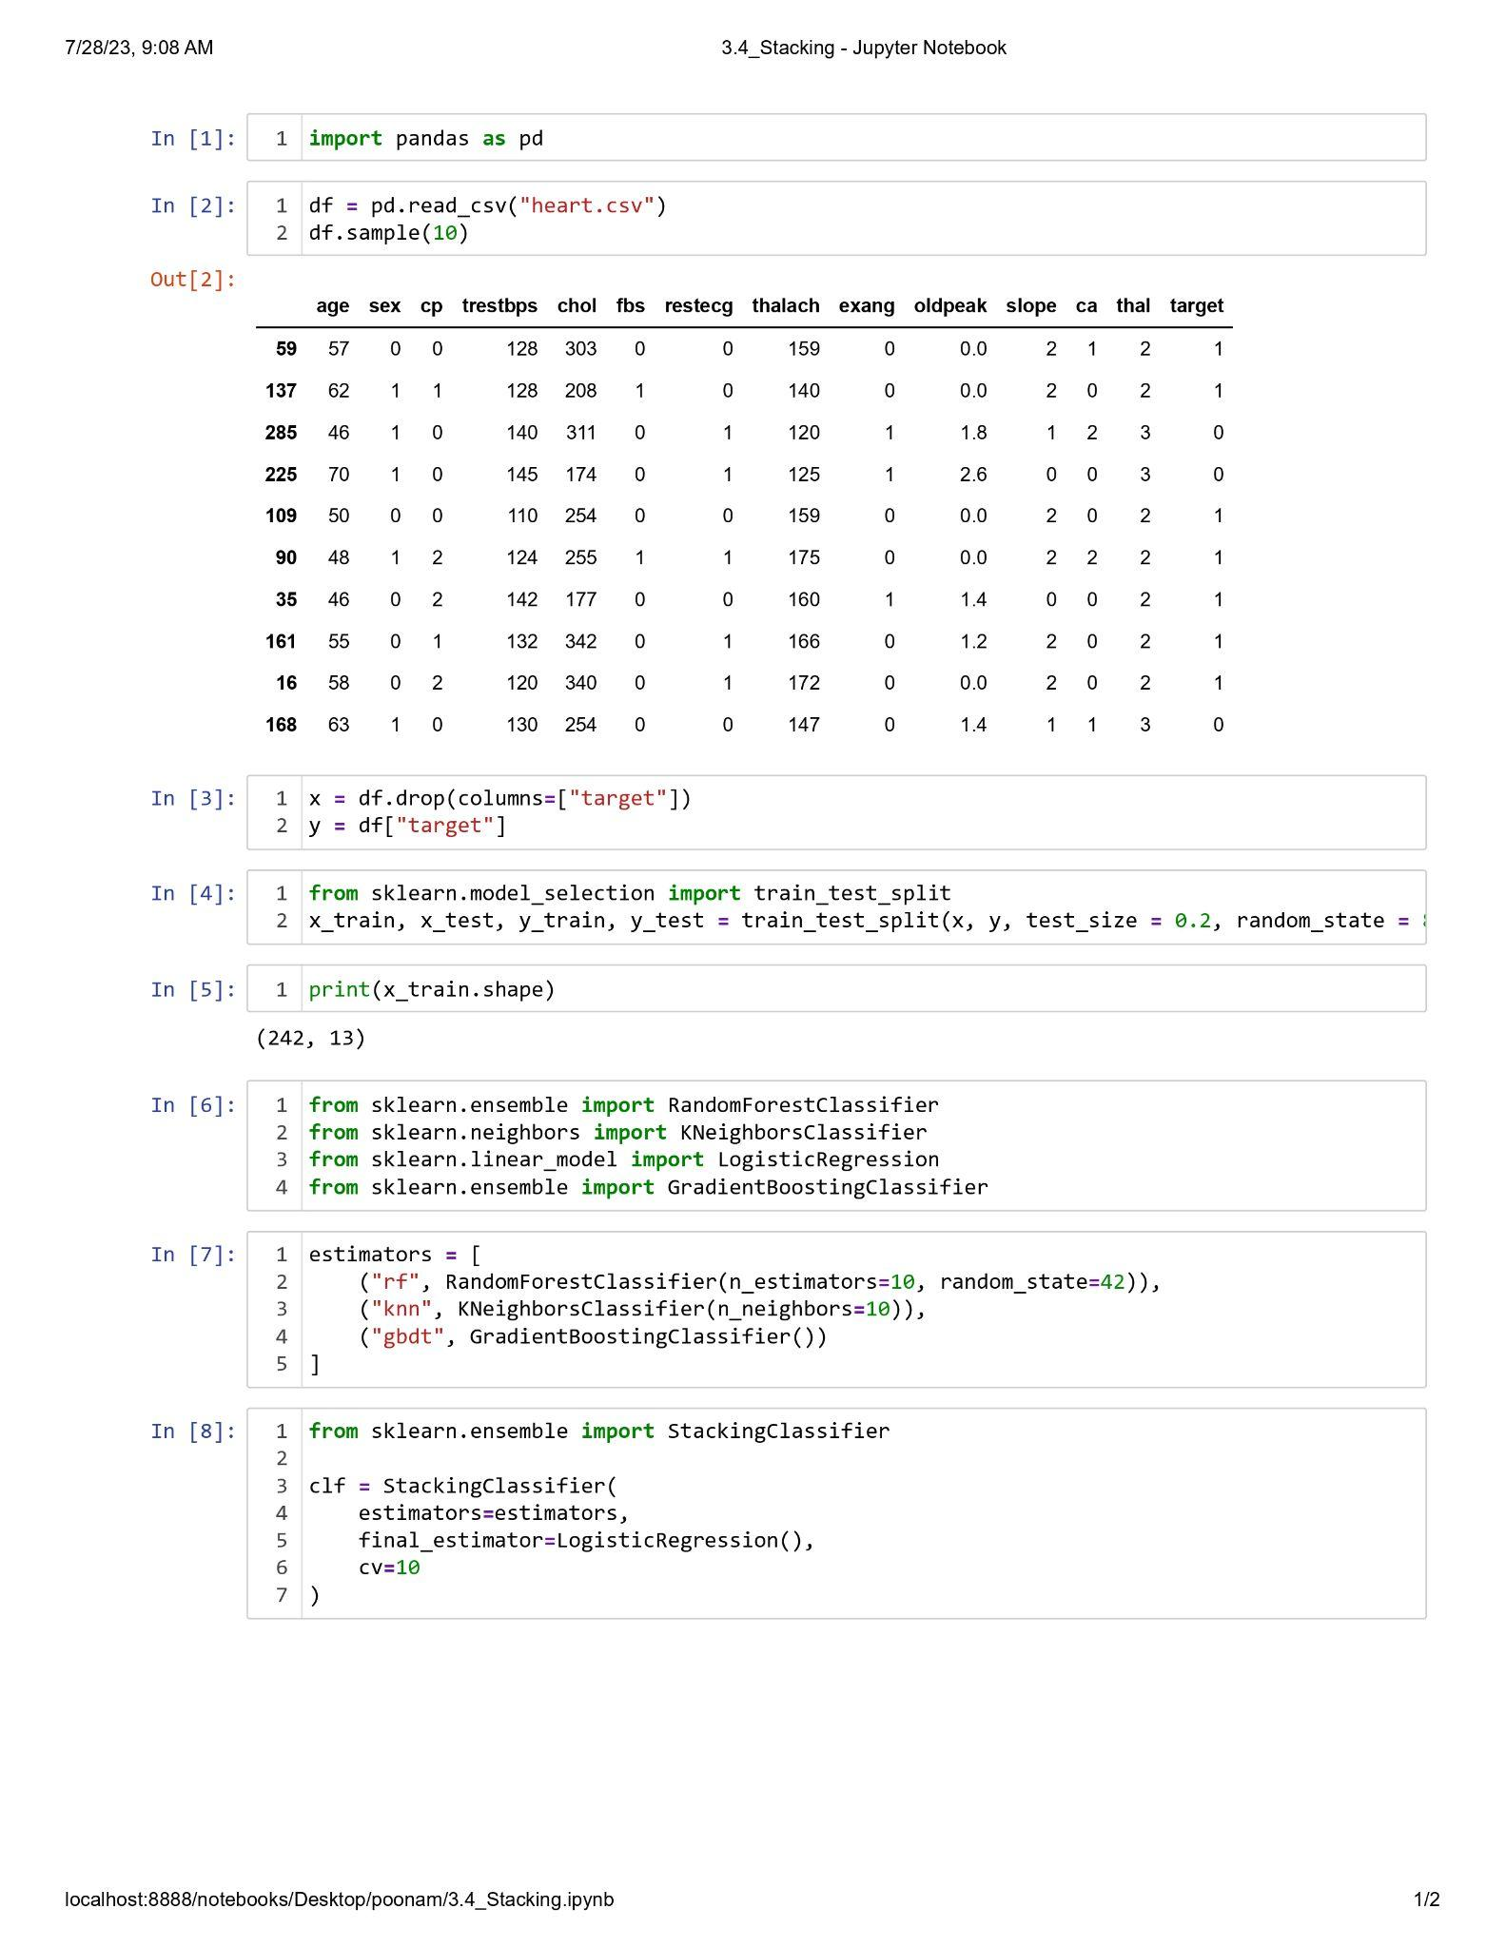

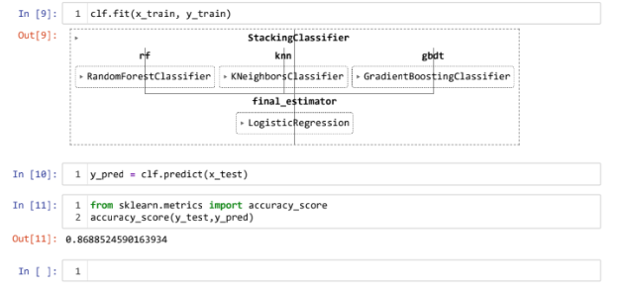

**Practical 3.5**

**Aim : Implementation of K-means Clustering.**

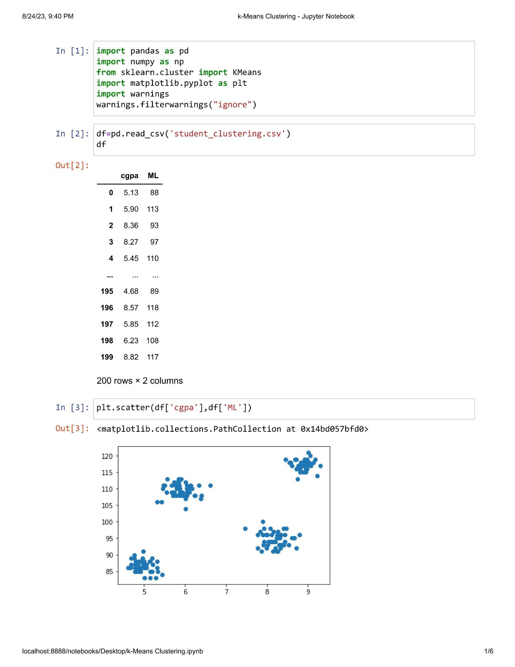

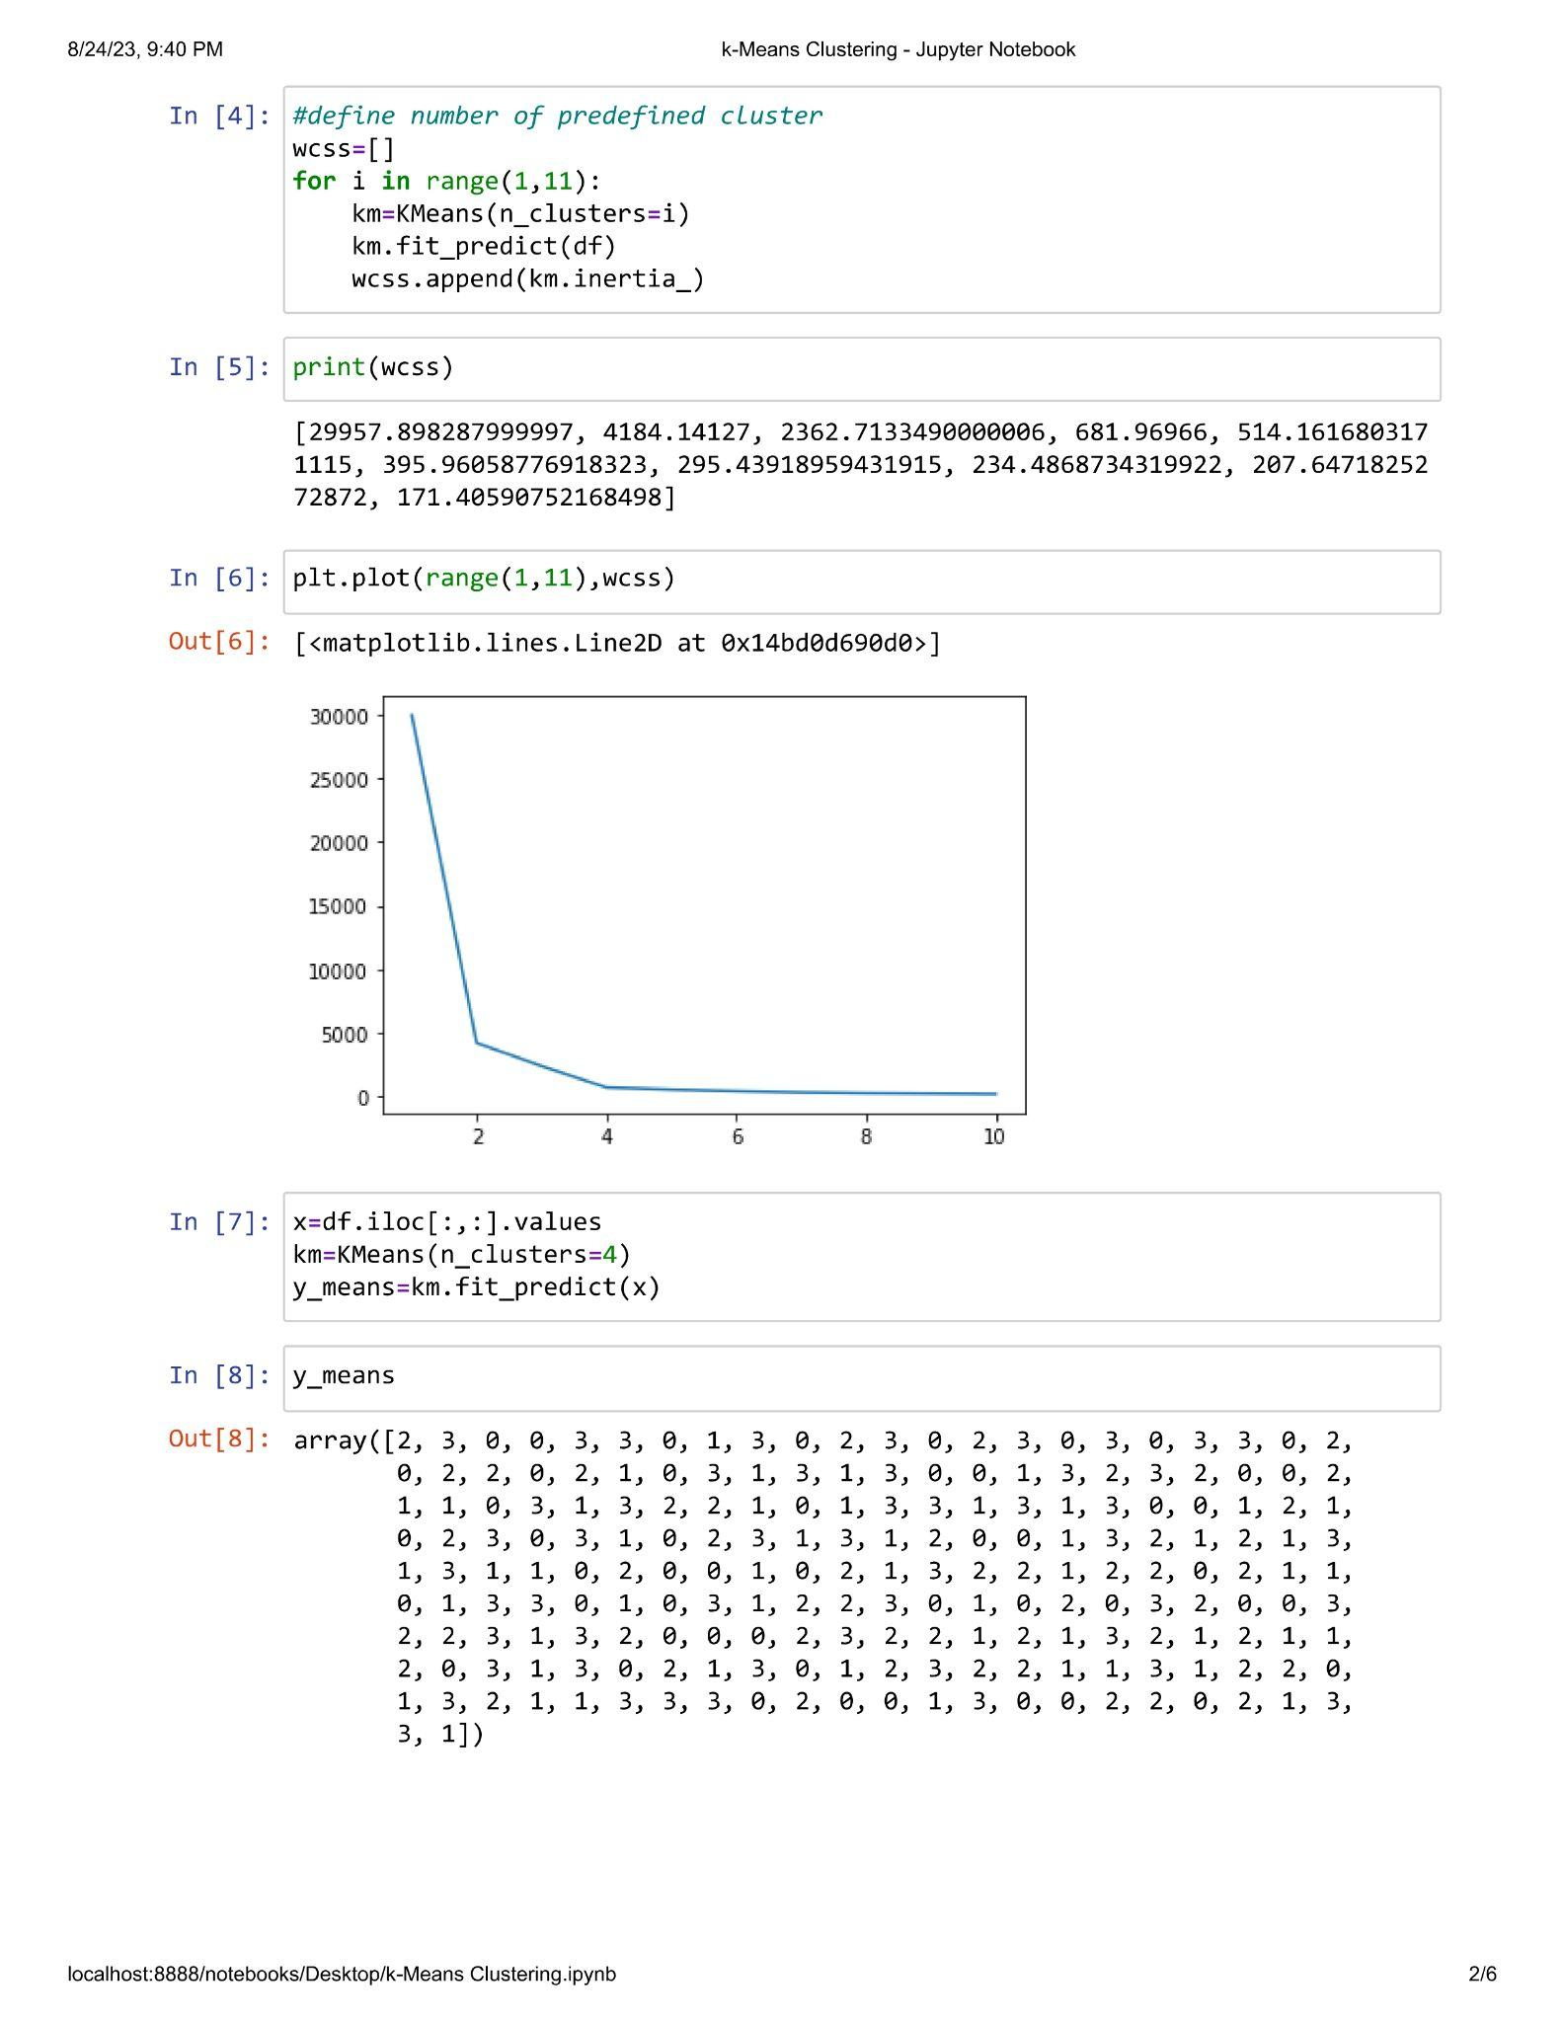

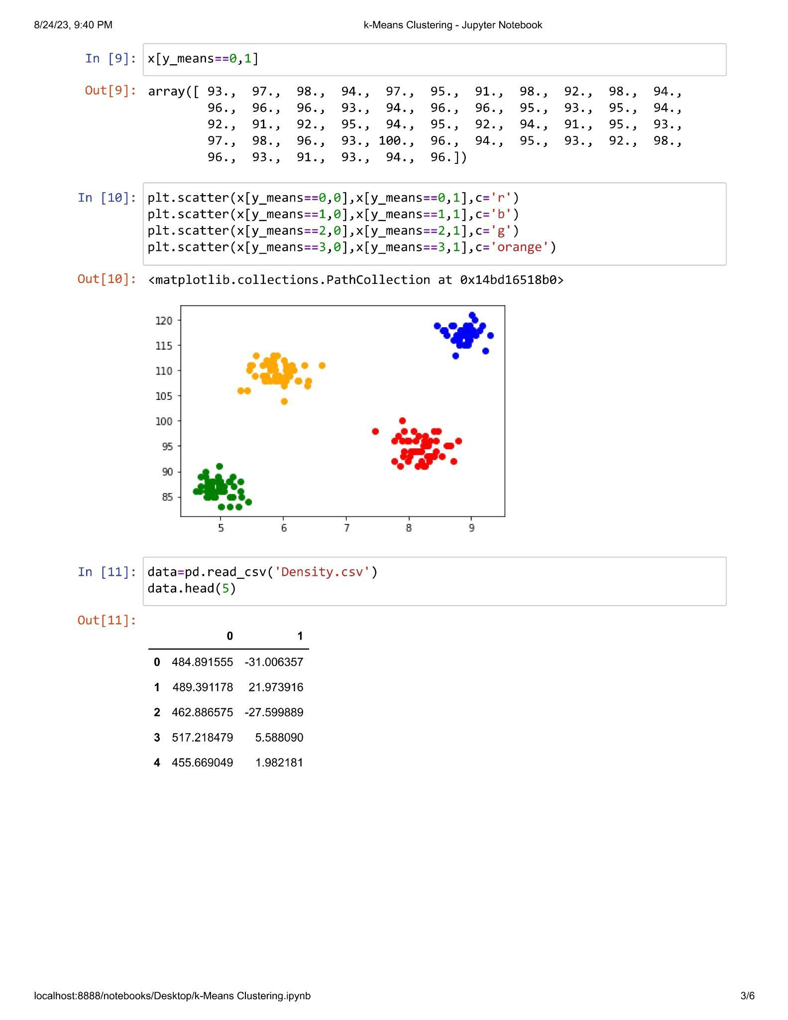

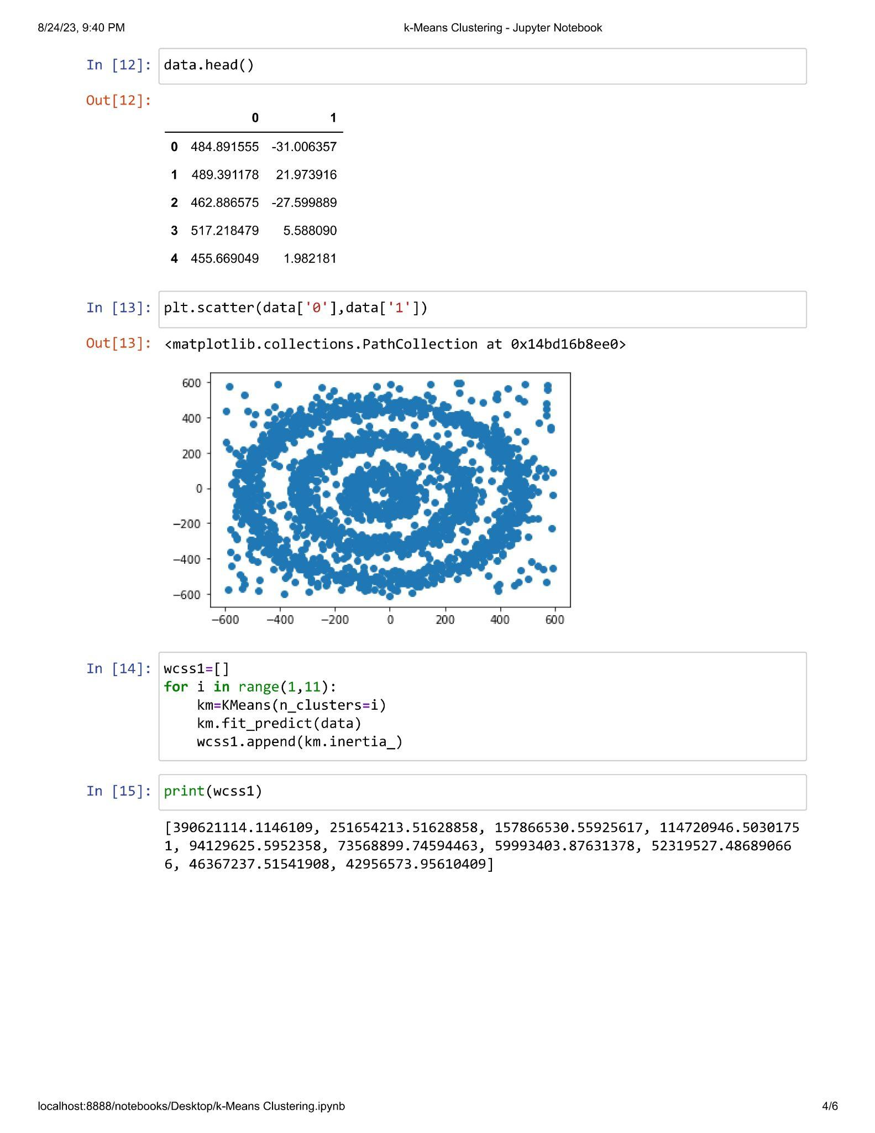

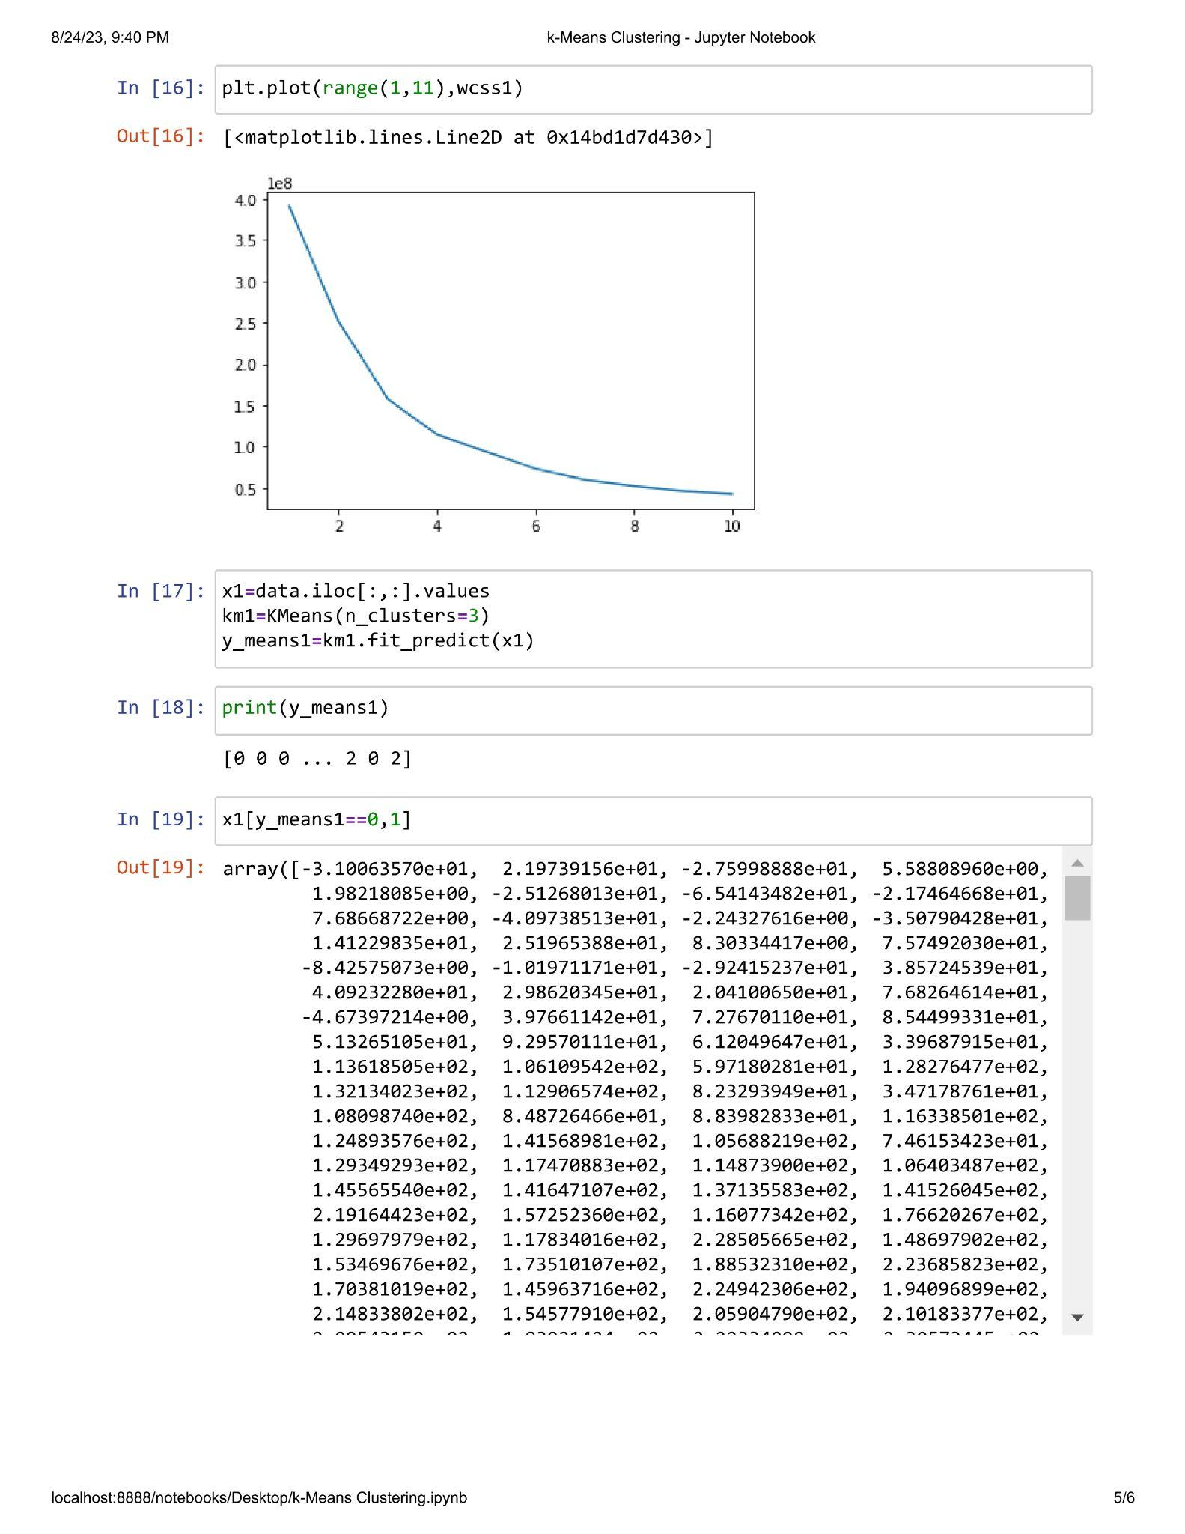

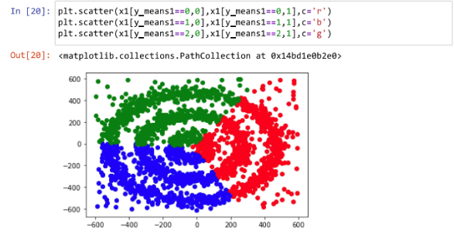

**Practical 3.6**

**Aim : Implementation of Agglomerative Clustering.**

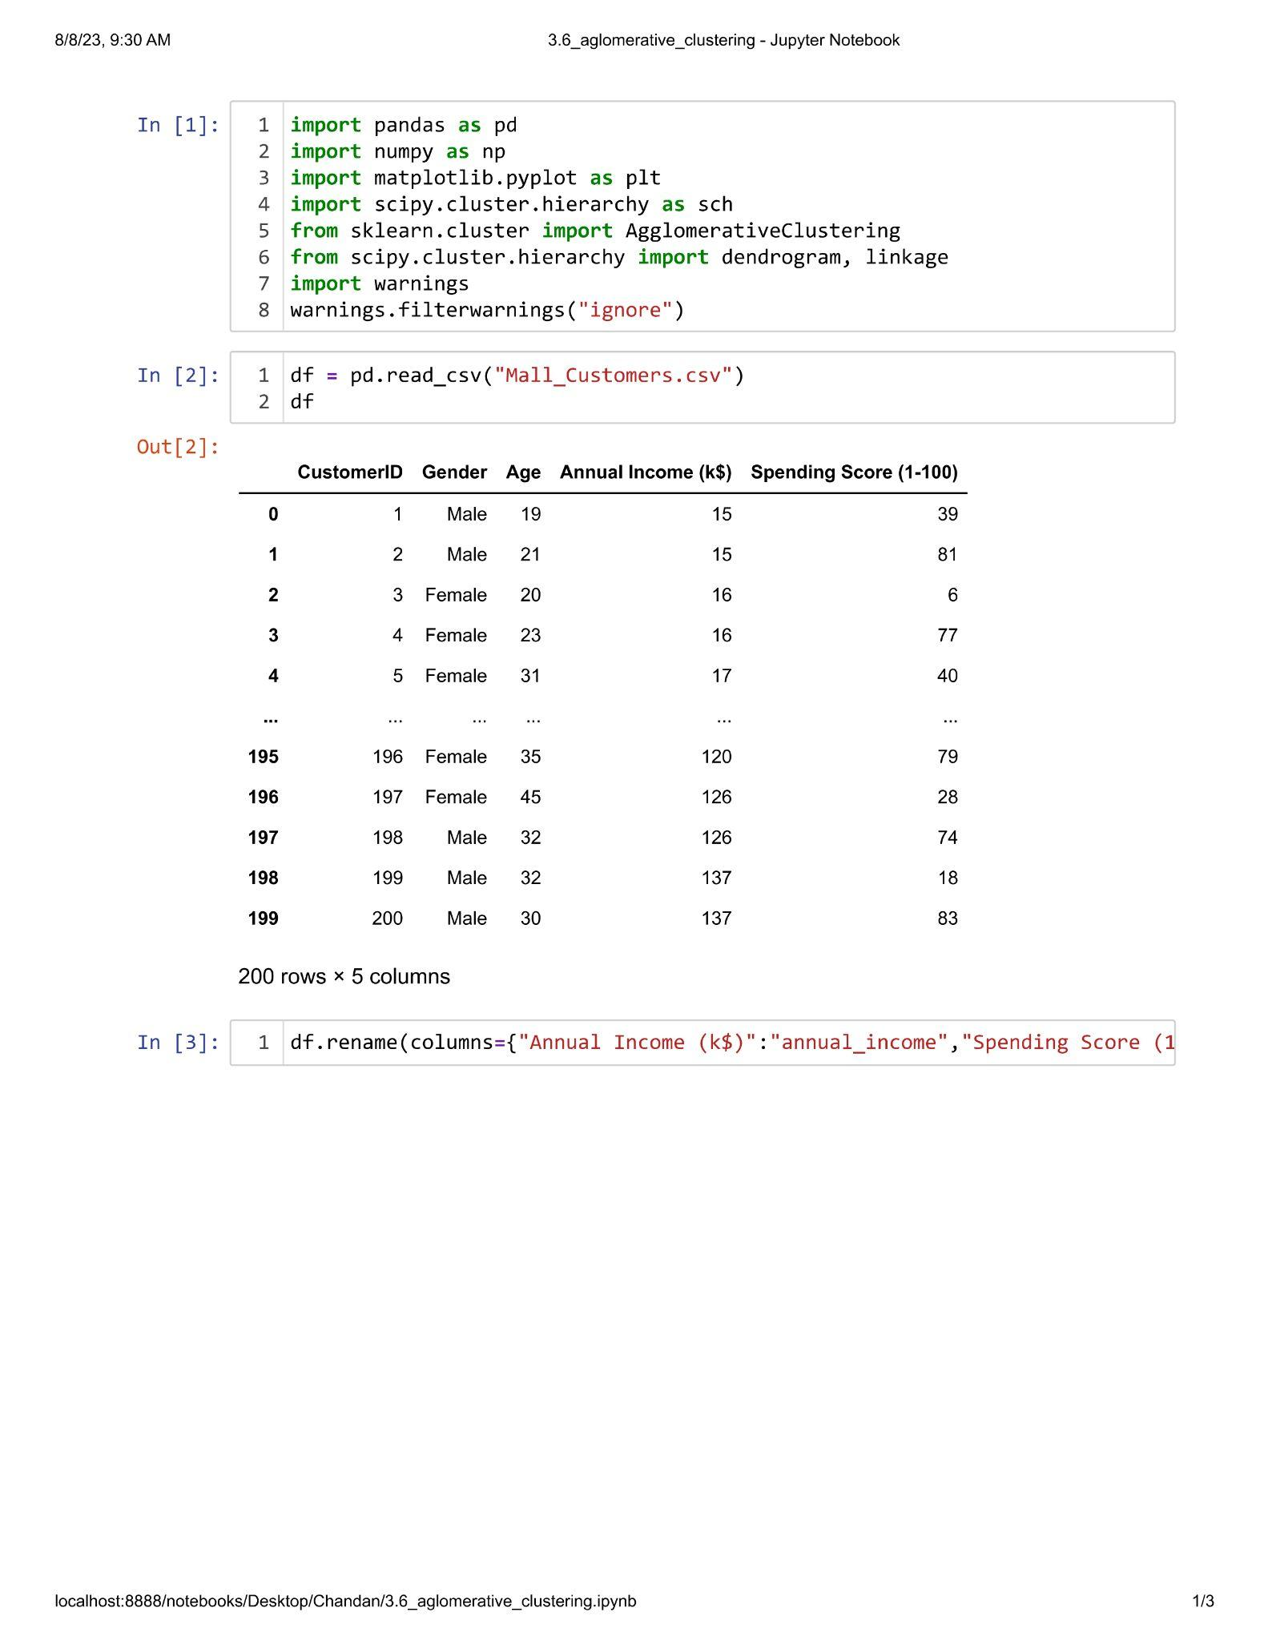

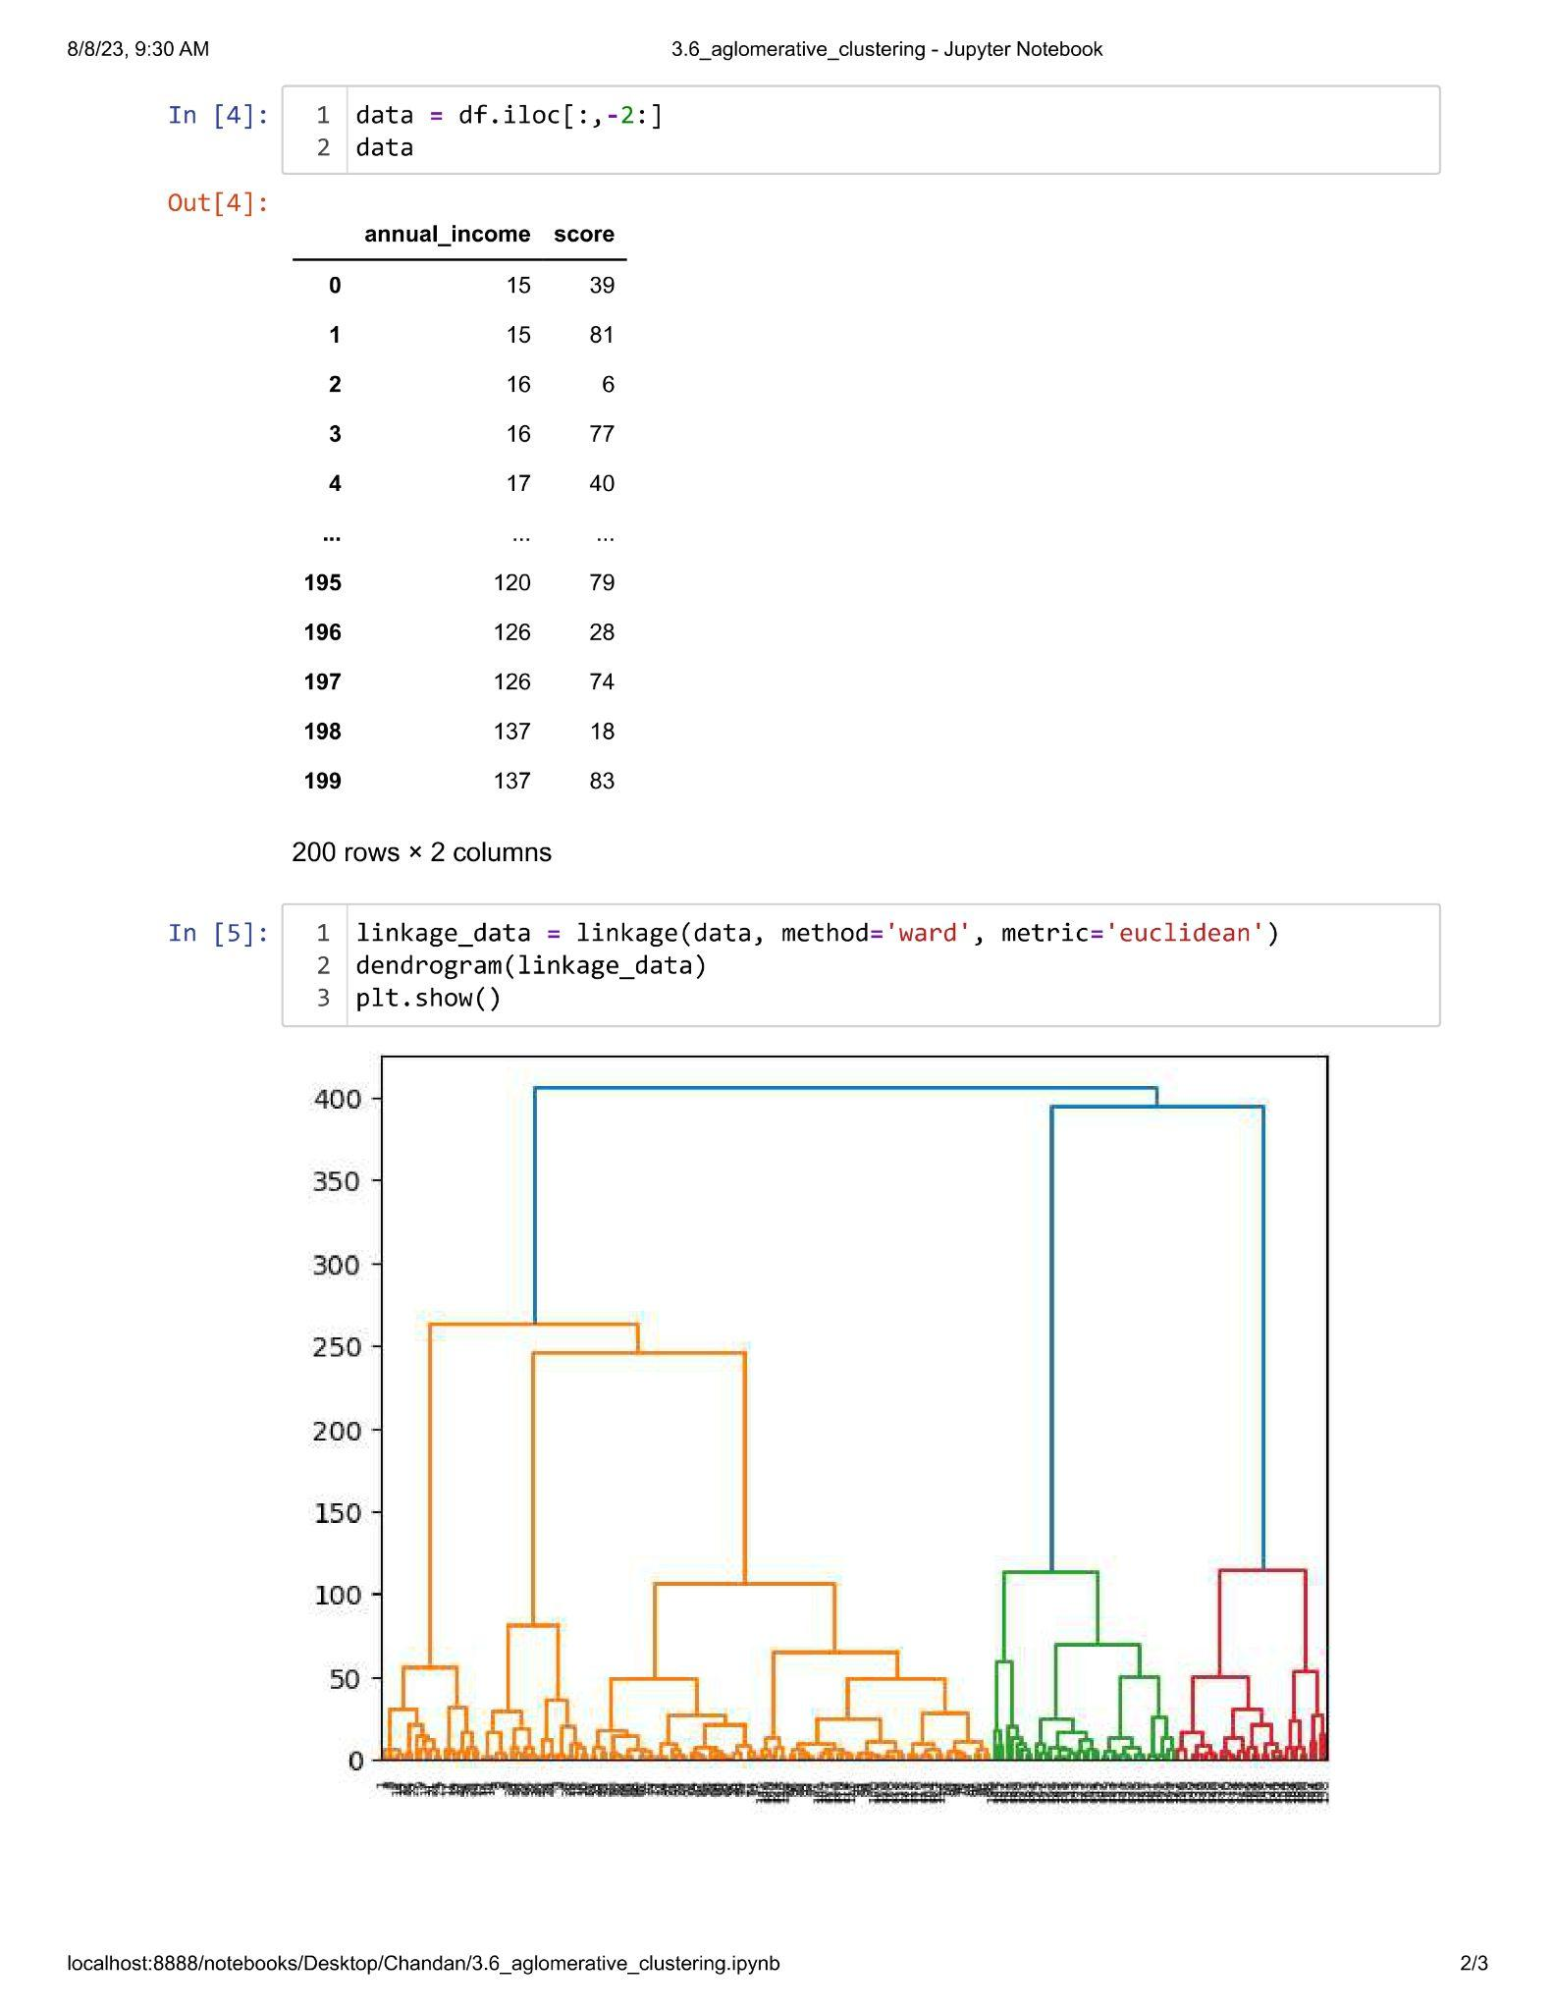

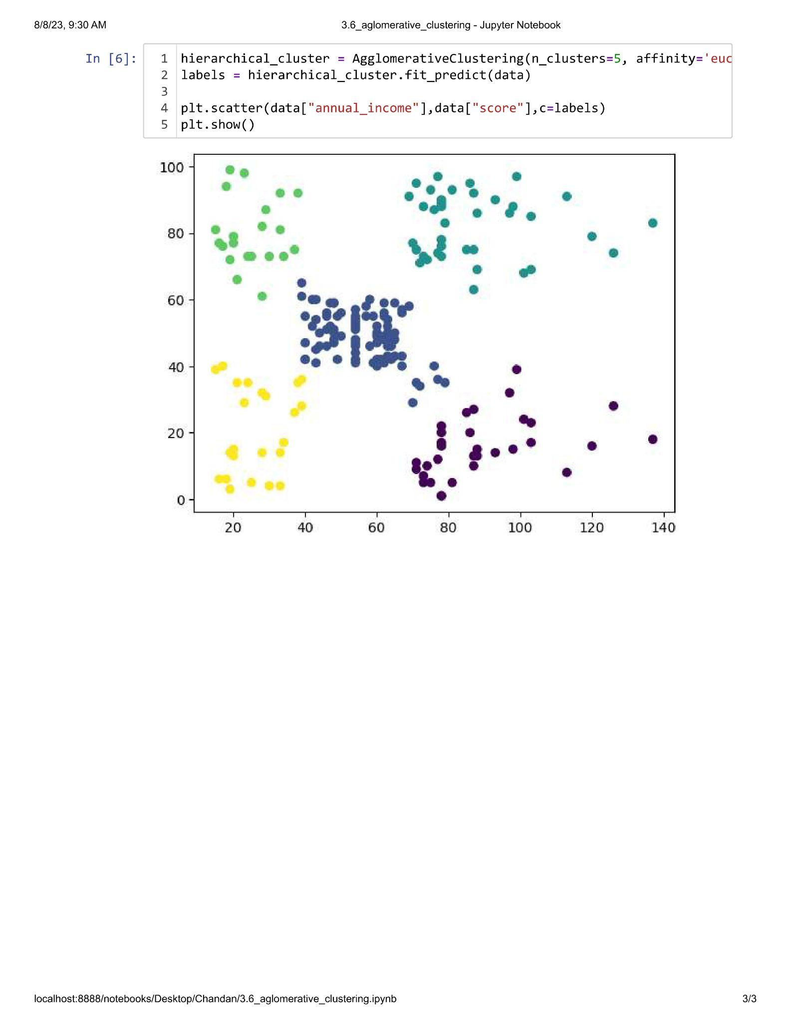

**Practical 3.7**

**Aim : Implementation of Density Based Clustering.**

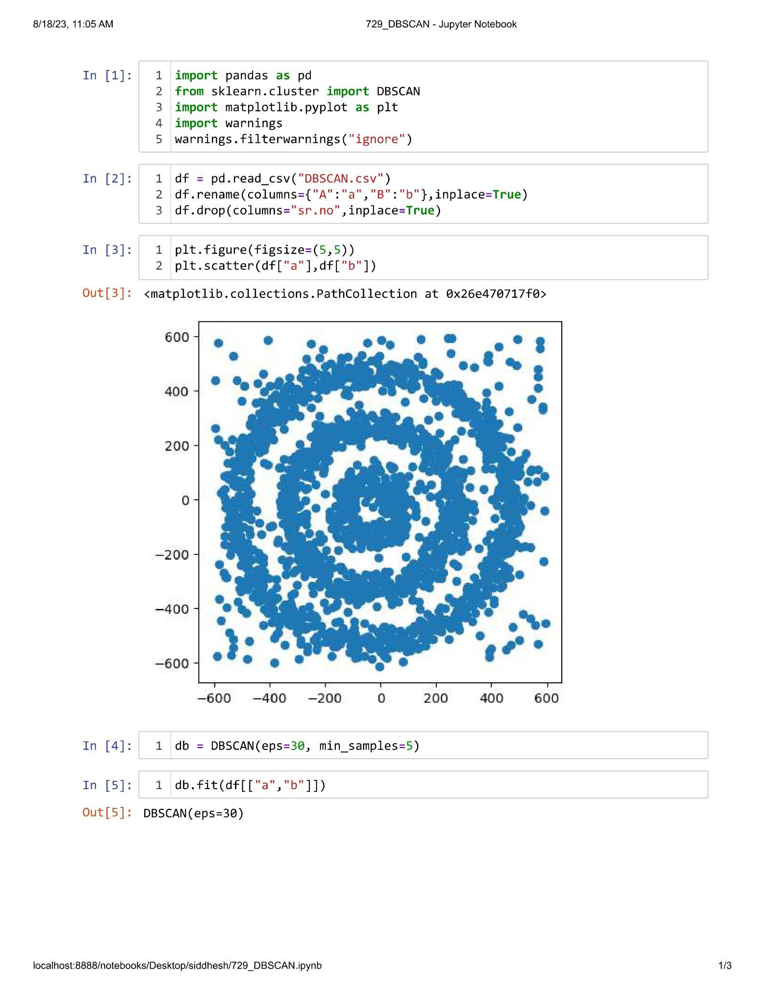

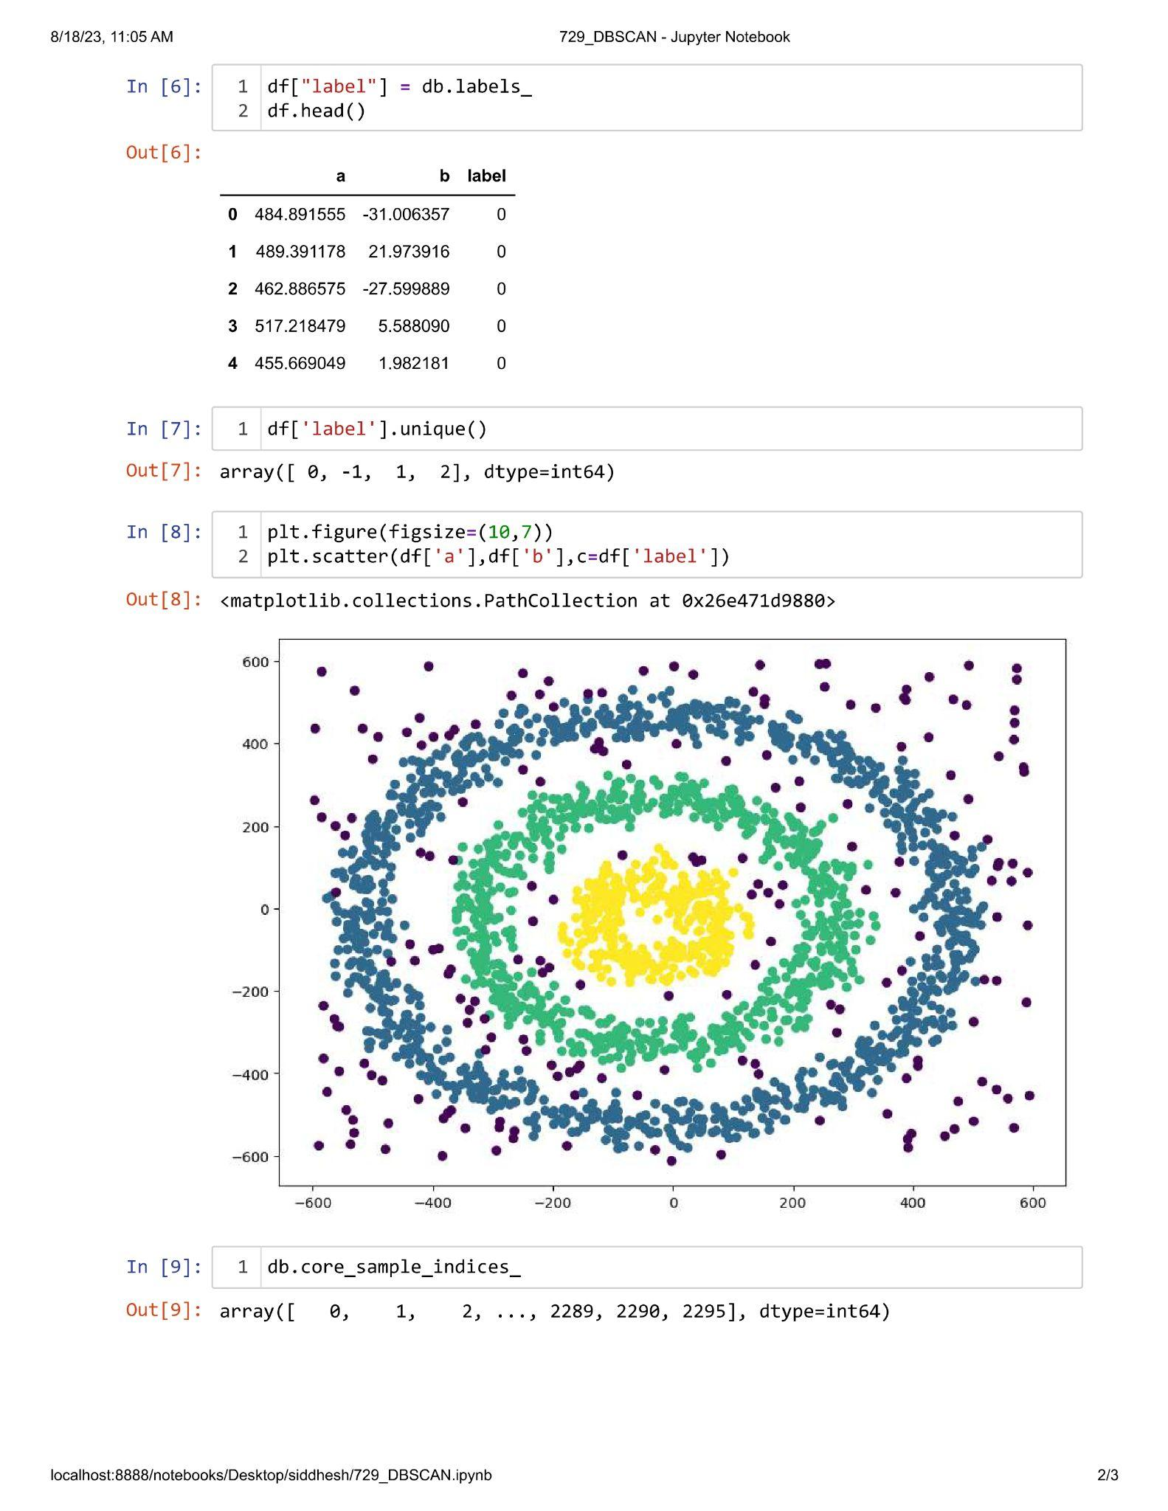

**Unit IV**

**Practical 4.1**

**Aim : Perform Market Basket Analysis using apriori algorithm.**

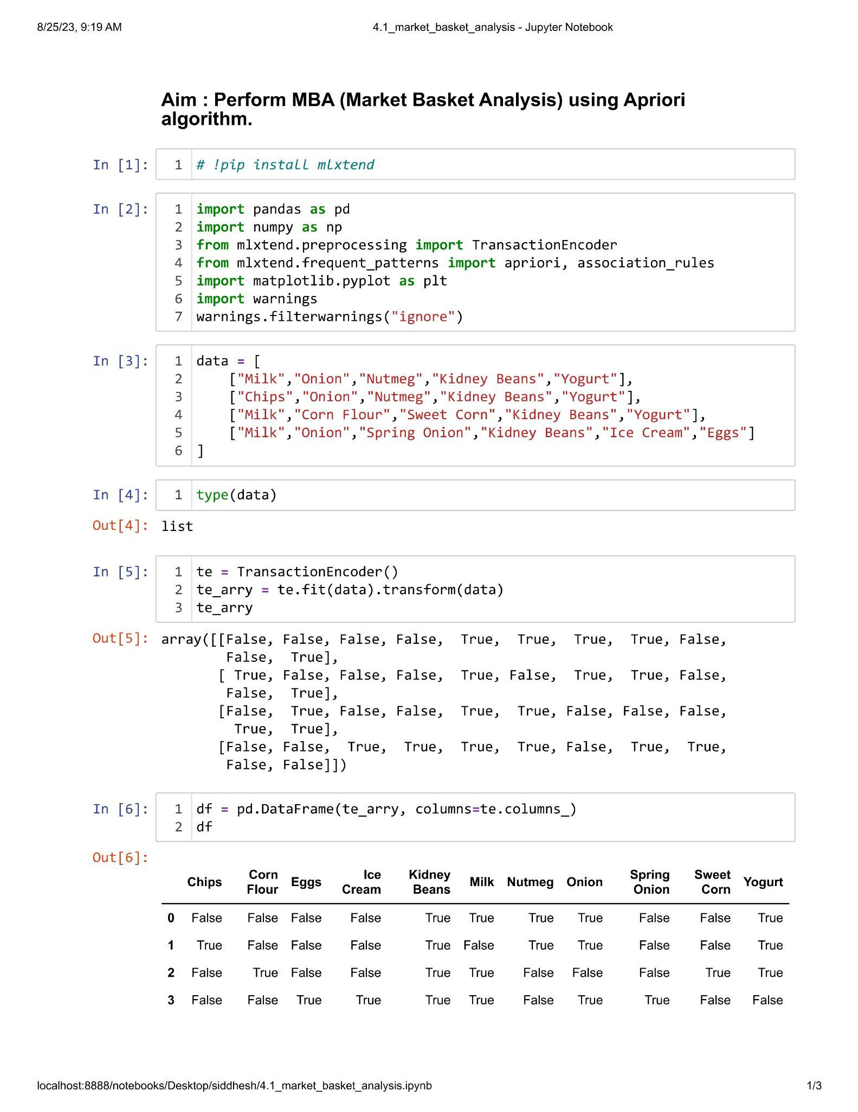

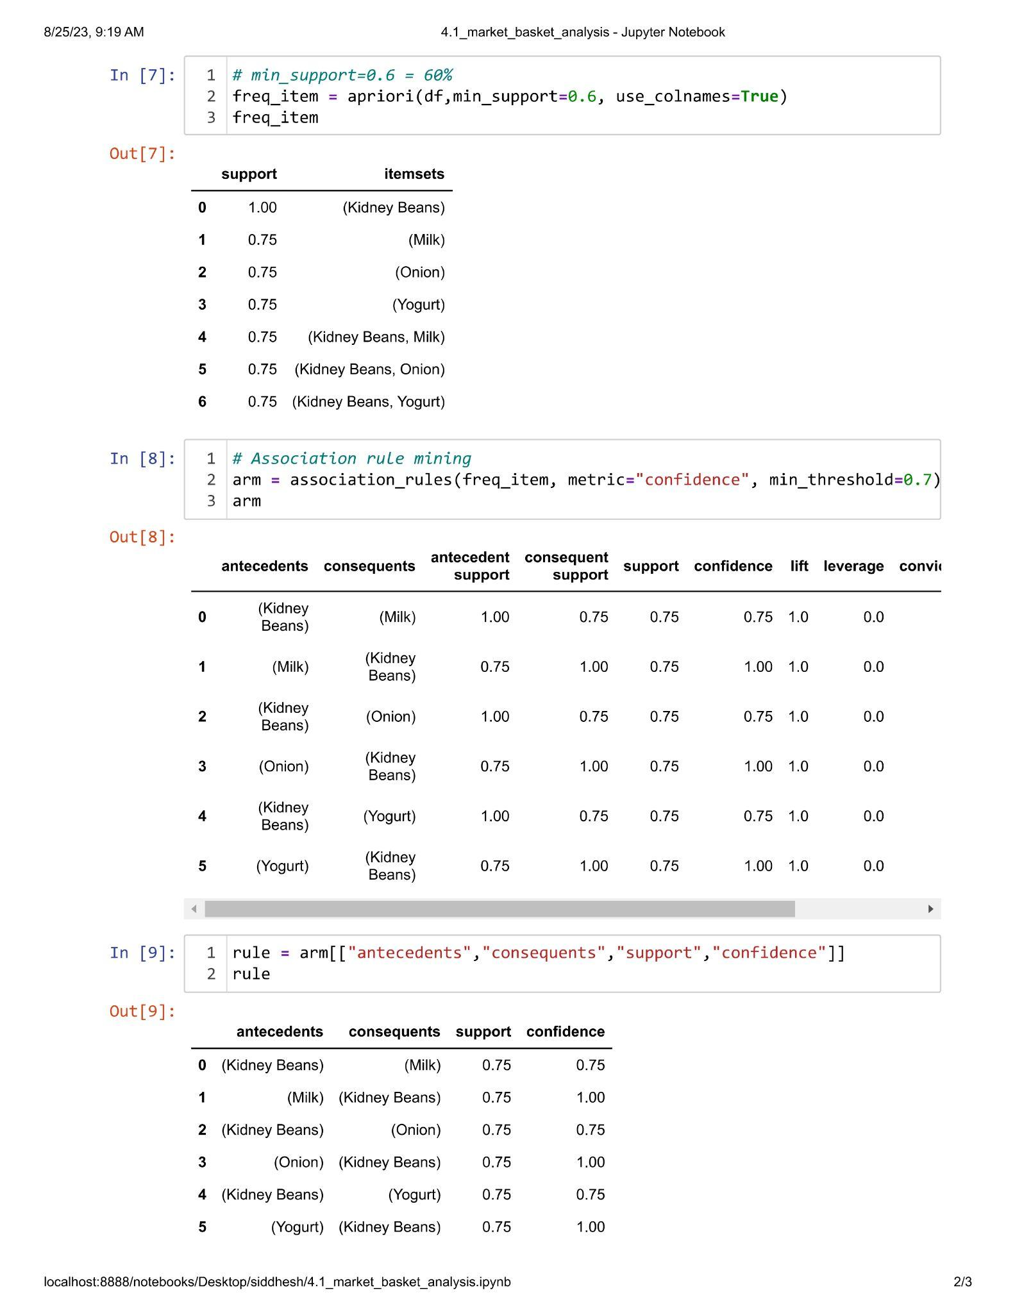

**\*\*\*\*\*End\*\*\*\*\***